**TIMEKEEPER**

# Project Plan & Increment-1



### Team – 3

* **Srinivas Potluri (74)**
* **Swaroop Chitiprolu (15)**
* **Sesha Sai Prasanna Chennupati (13)**
* **Sampath Boddeti (6)**

1. **Introduction**

**TimeKeeper:**

In the present world, Health and Time are the two most important aspects in everyone’s life. So, this application comes with a reminder and alarm for different types of purposes which will be explained in the further proceedings.

### Objectives and Project goal (Revised)

* 1. **Goal**

The foremost objective of this application is to keep a person up to date with the things that he/she needs to do on a specific date and on a specific time and to make him/her punctual at their work and things that need to be done.

### Specific Objectives

* + 1. Notifying the users about the things such as Assignments, Taking Medicines, Shopping.
    2. Waking the user using an alarm
    3. Capable of storing notes that are important to the user

### Specific Features

* + 1. The Application uses Voice to remind the things that need to be done.
    2. The Application uses the Google Maps API to notify the destination and the things nearby in the path of your travel.
    3. The Application uses various types of games to wake up the user.

### Significance

The Application provides a combination of reminder, wake up alarm and Notes for the user without using different applications.

### Project Plan

**Zen-Hub Screenshot:**

**Issues:**

We had the issues regarding

Creating Logo & Title, Designing UML and Class Diagrams, Designing Wireframe Diagrams, Login and Registration Pages, Home Page, Running the Application in Mobile, Preparing Documentation.

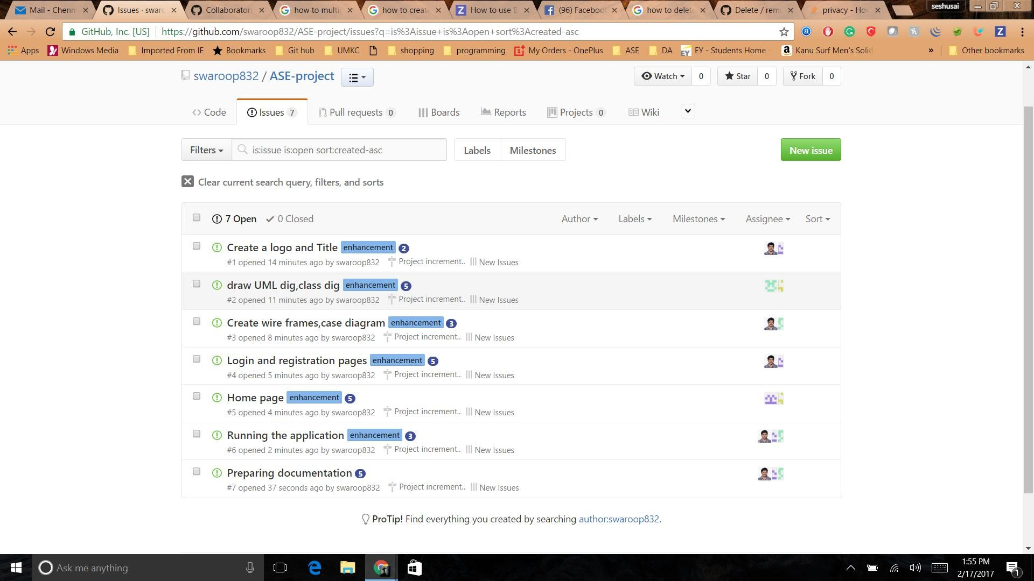

### Project Timeline, Members, Task Performed

The below screenshot gives an idea regarding the issues and state of the issues.

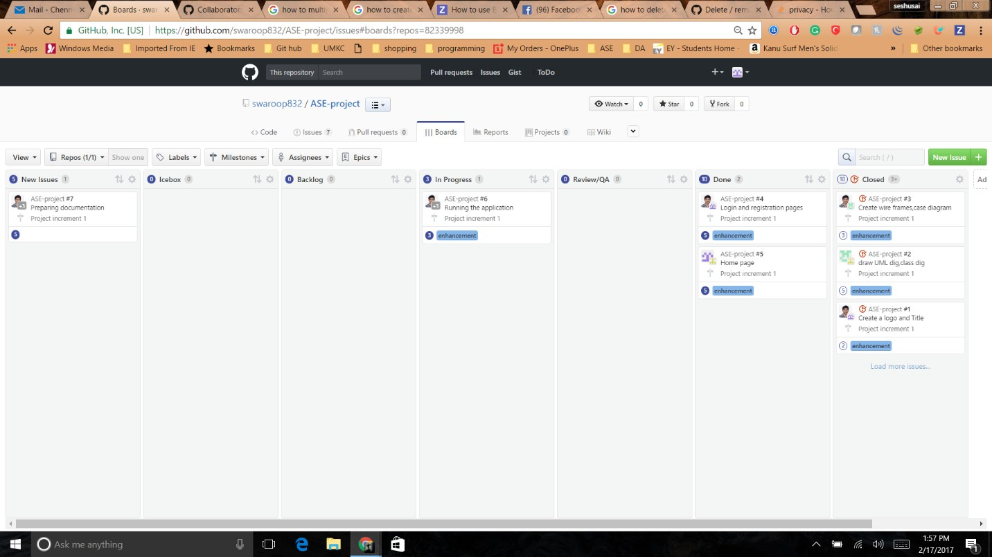

### Burn-Down Chart:

The Burn-Down chart was created based on issues that we faced.

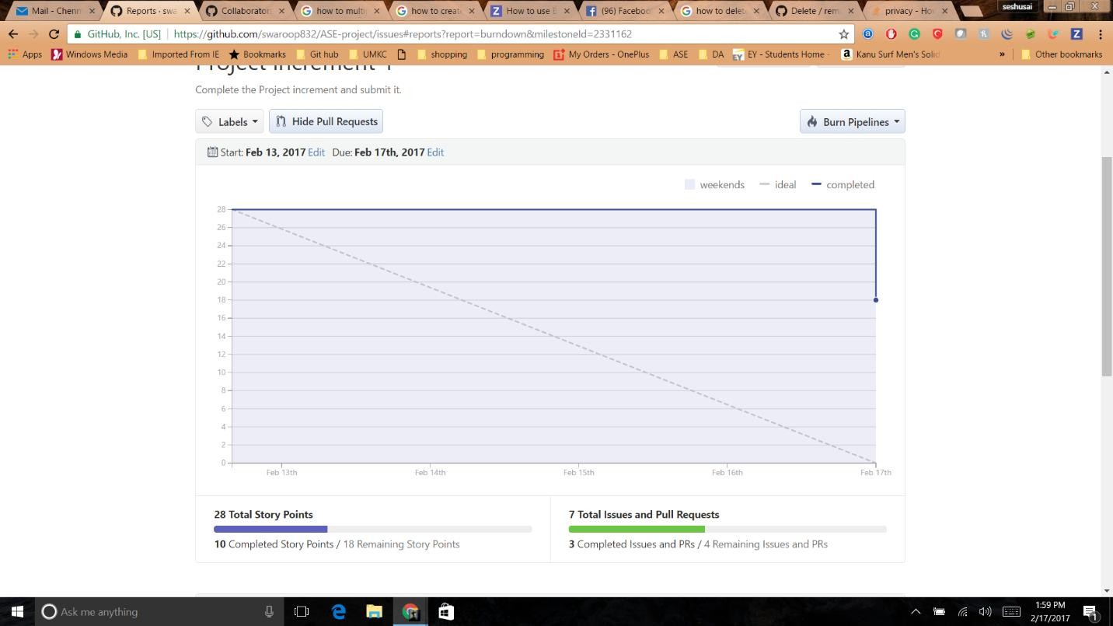

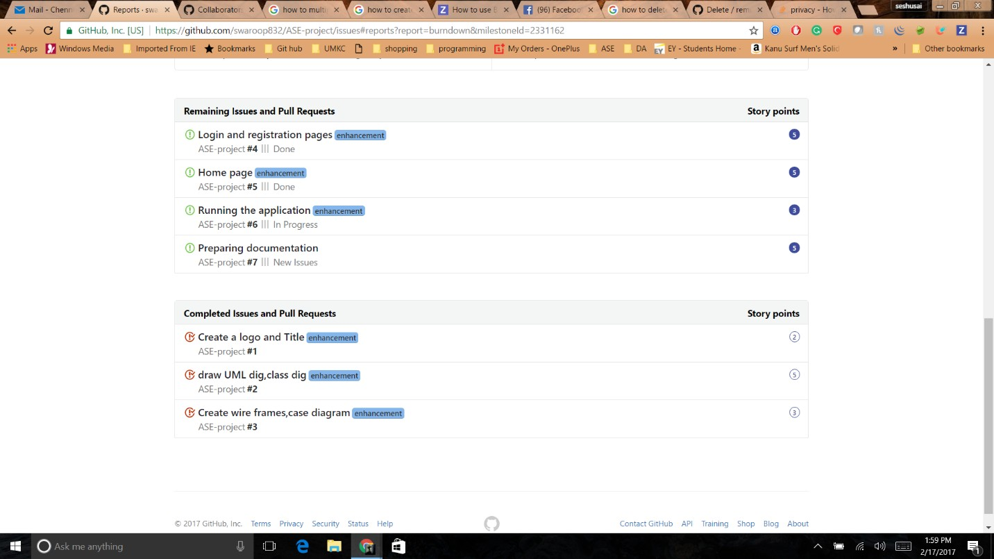

### 1st Increment Report

**4.1 Services/API**

**4.1.1 API’s we Used**

**4.1.1.1 Facebook API:**

We did integrate Facebook API to the application.

We shall use below mentioned API’s in the upcoming increments to implement the technologies.

* We shall also use Google Maps API and Calendar API

### Design of Features in detail:

**Wireframes**

* + 1. **Login Page (wireframe):**

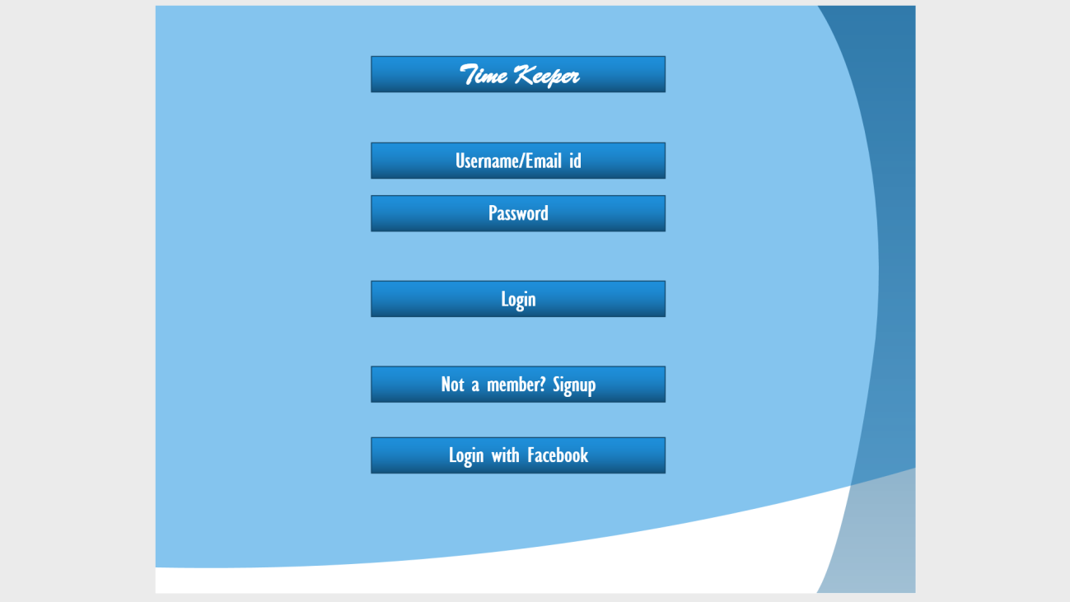

* + 1. **Register Page (wireframe):**

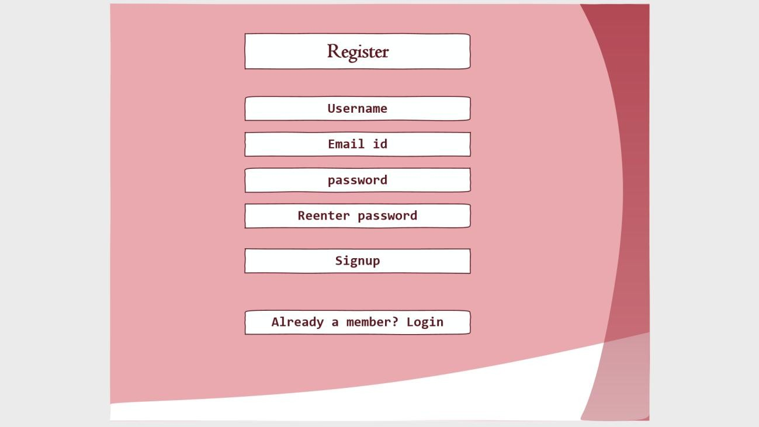

* + 1. **Home Page (wireframe):**

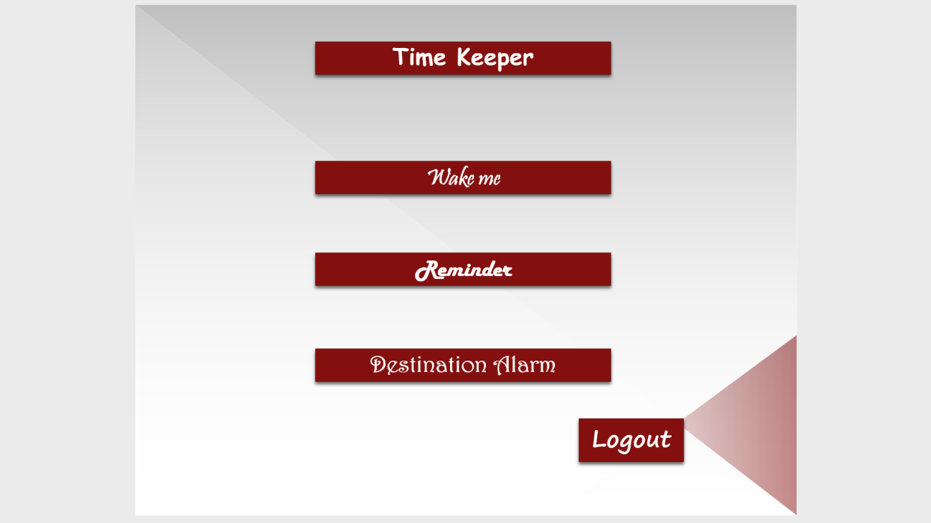

**Class Diagram:**

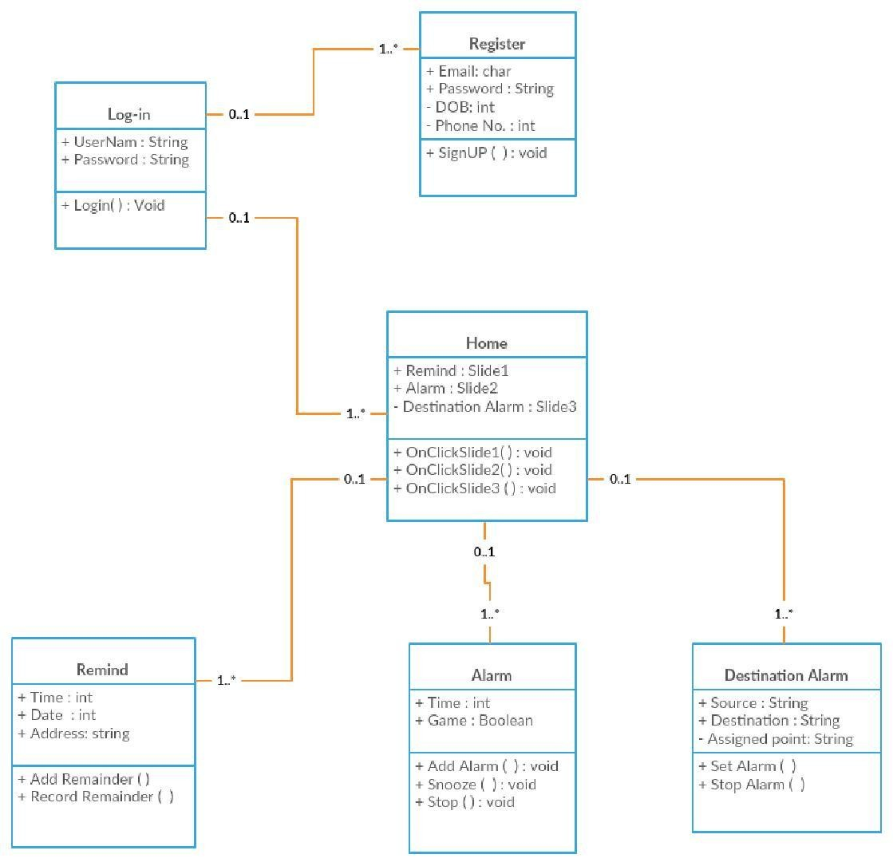

**Case Diagram:**

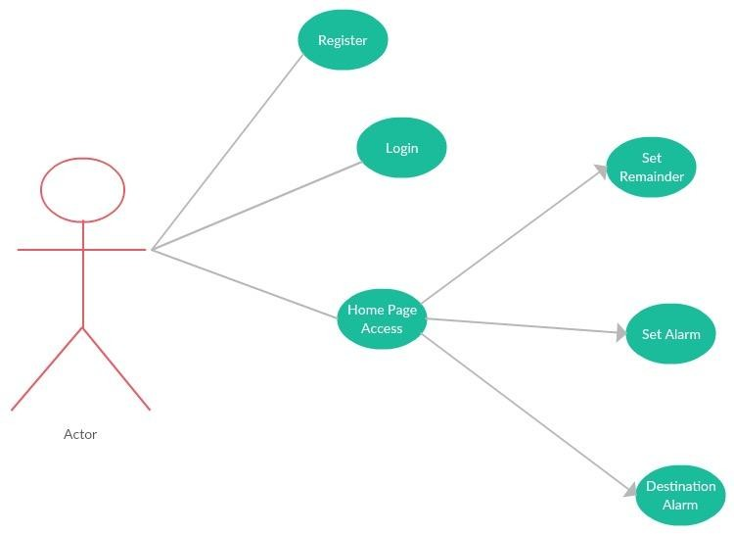

### Sequence Dig:

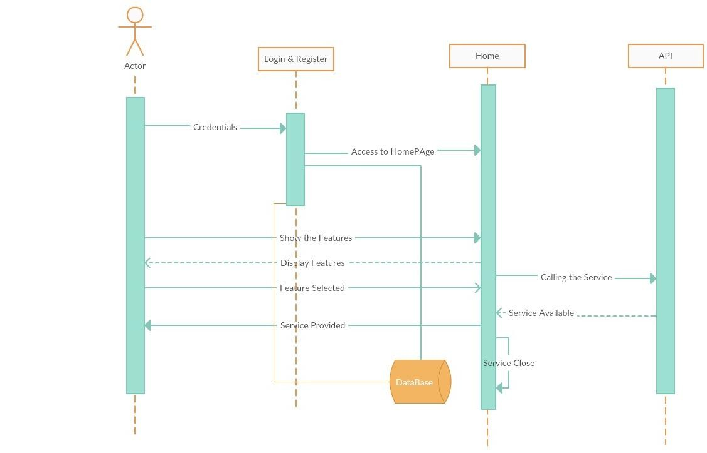

### Architecture:

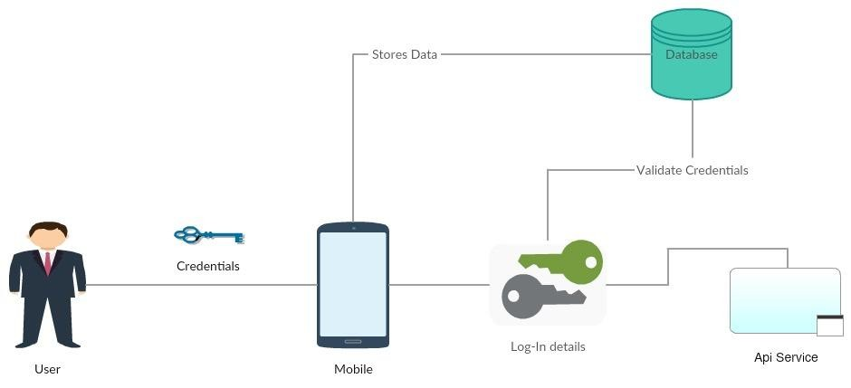

**User Stories:**

|  |  |  |
| --- | --- | --- |
| **I am a** | **My Purpose.** | **Benefit** |
| **User.** | **Remind**  Set Remainder | Notifies the activities. |
| **Wake**  Set Alarm | Wakes me up with a interesting puzzle. |
| **Notes**  To store some quotes and make Notes which are important | Helps in storing data in the way of taking notes and some might have a habit of writing dairy, so they can use this. |

**Testing**

**Cases for Register and Login Pages:**

|  |  |  |  |
| --- | --- | --- | --- |
| **Cases** | **Description for Test case** | **Results Expected** | **Genuine Result** |
| Login | Please enter Invalid Username & Password | It is Error | It is Success |
| Login | Please enter Invalid Username & Valid Password | It is Error | It is Success |
| Login | Please enter Valid Username & Invalid Password | It is Error | It is Success |
| Login | Enter Valid Username & Valid Password | Logged into Home Page | It is Success |
| SignUp | Email ID should end with  @mail.com | Invalid Mail | It is Success |
| SignUp | Length of Password should have minimum 8 characters | Password Weak | It is Success |
| SignUp | Password column and Confirm Password column should match | Registers shall be Directed to Login Page | It is Success |

1. **Project Implementation**

We implemented the TimeKeeper App in Android Studio and run it on the Android device. Screen shots shows how the application is run.

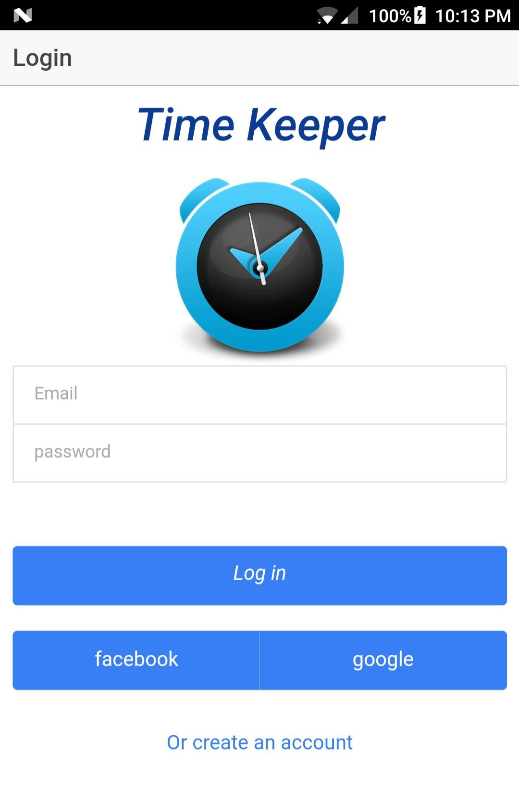

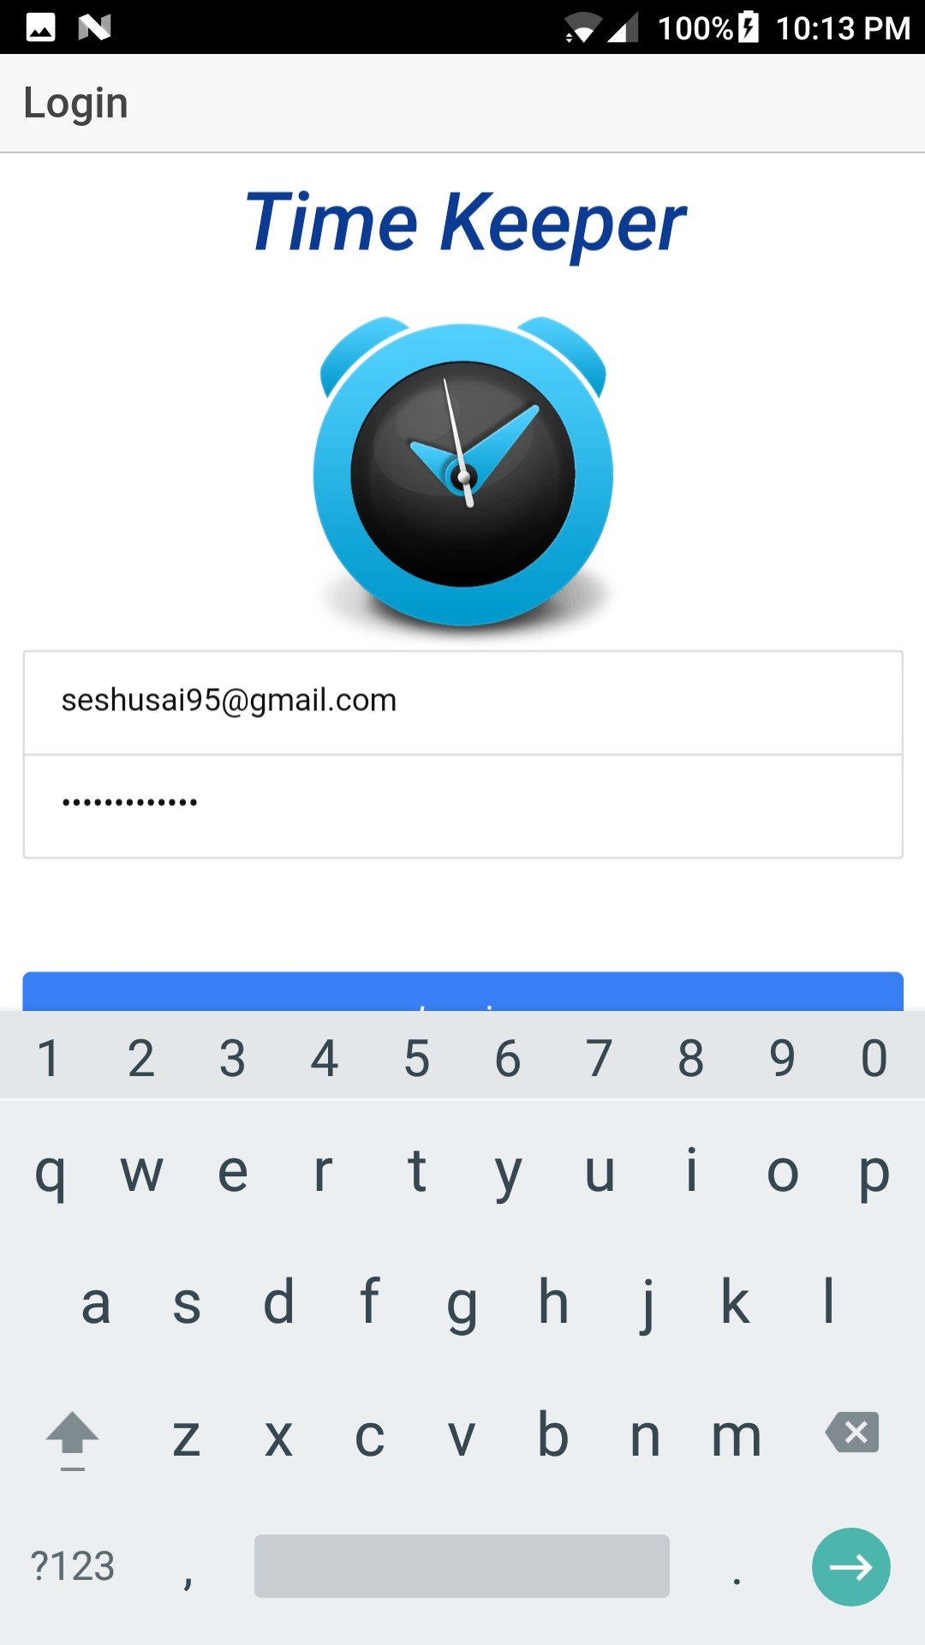

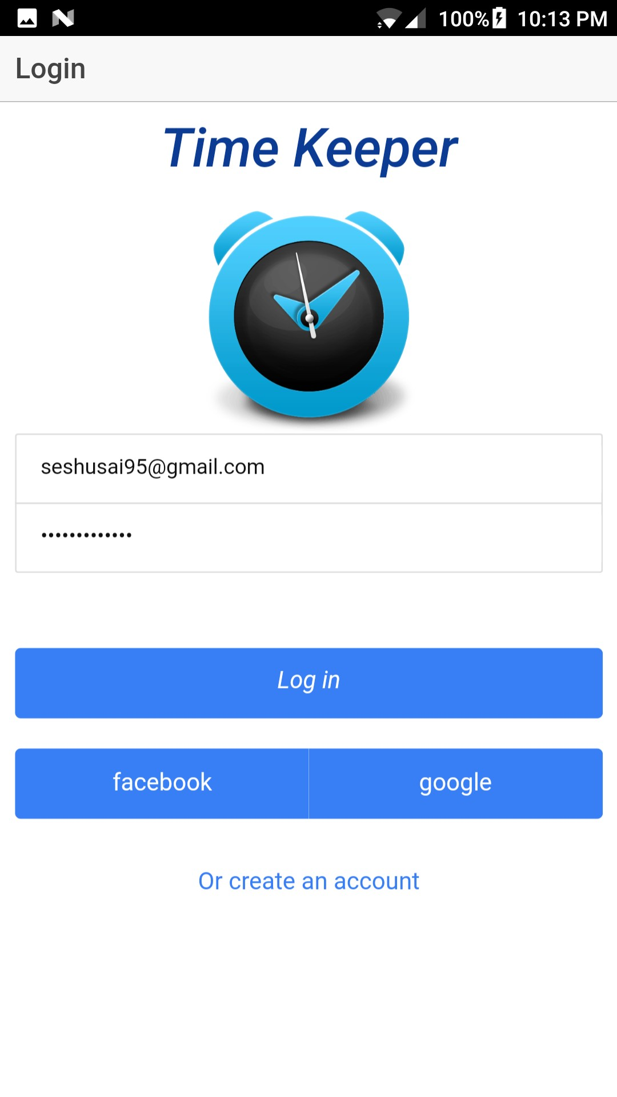

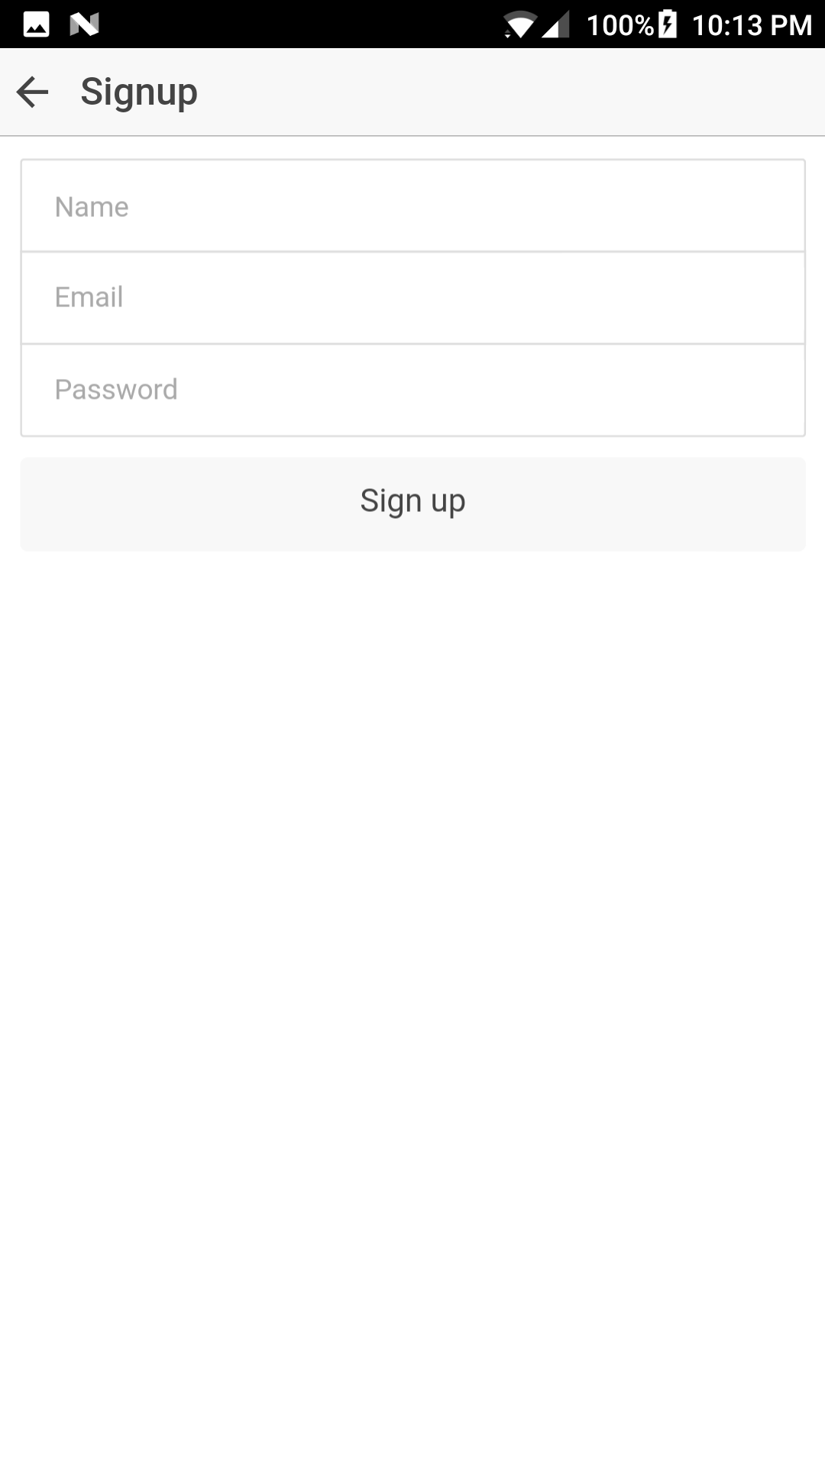

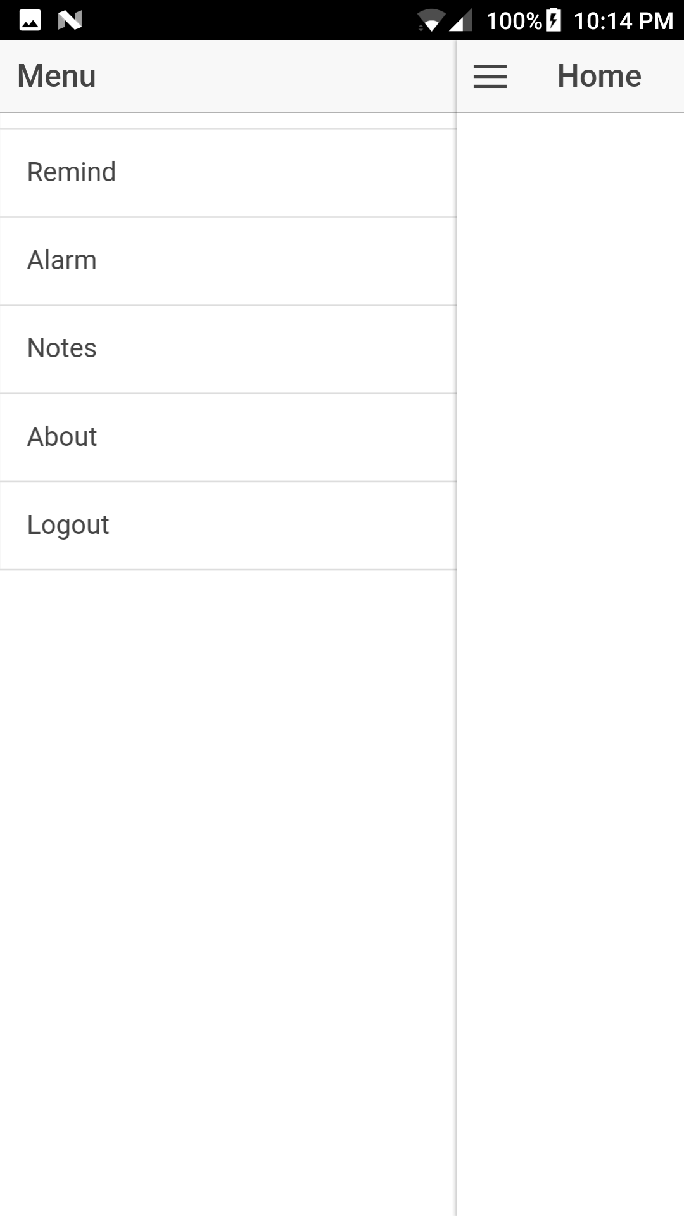

# Project Plan Increment-2

### Project Timeline, Members, Task Performed

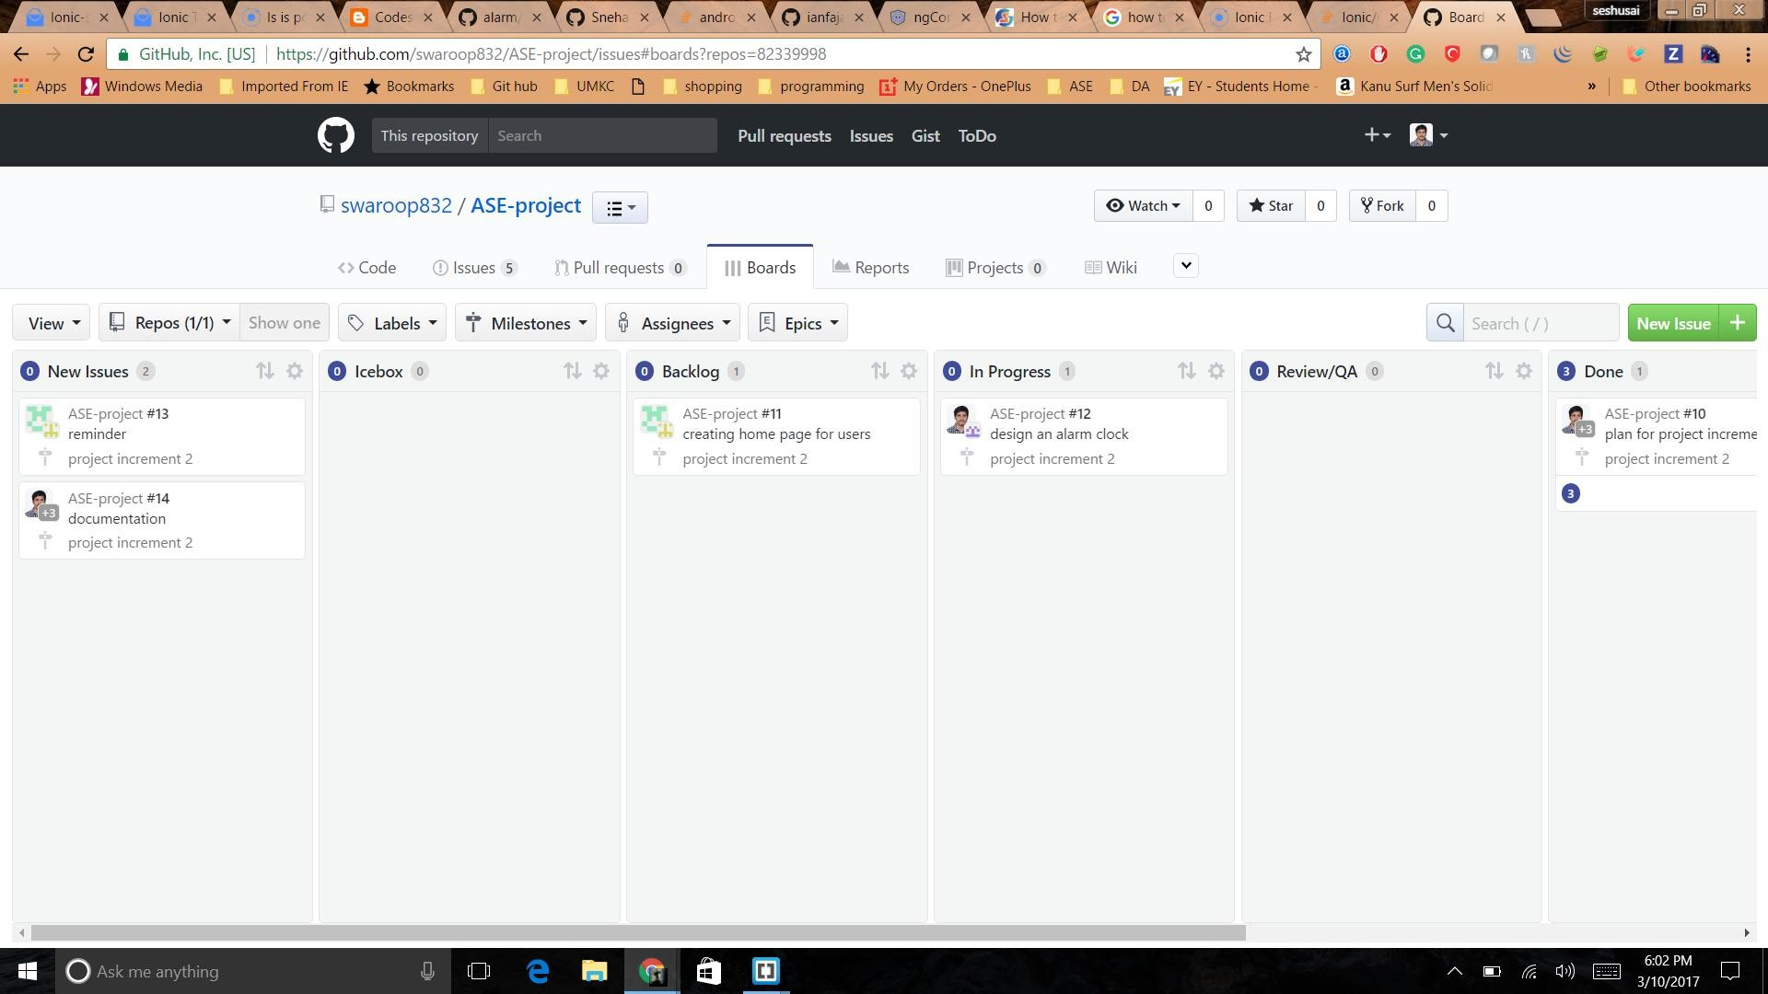

### Issues:

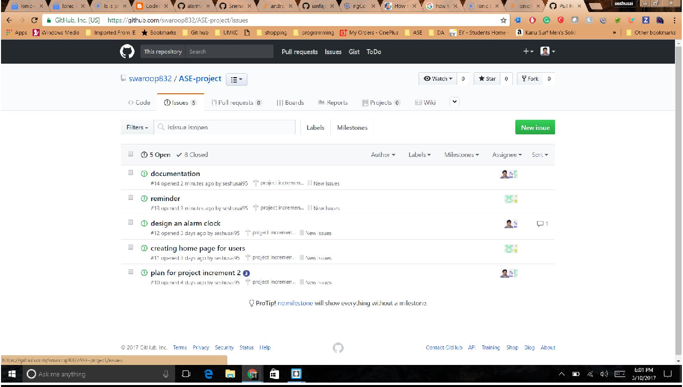

**Burn-Down Chart**

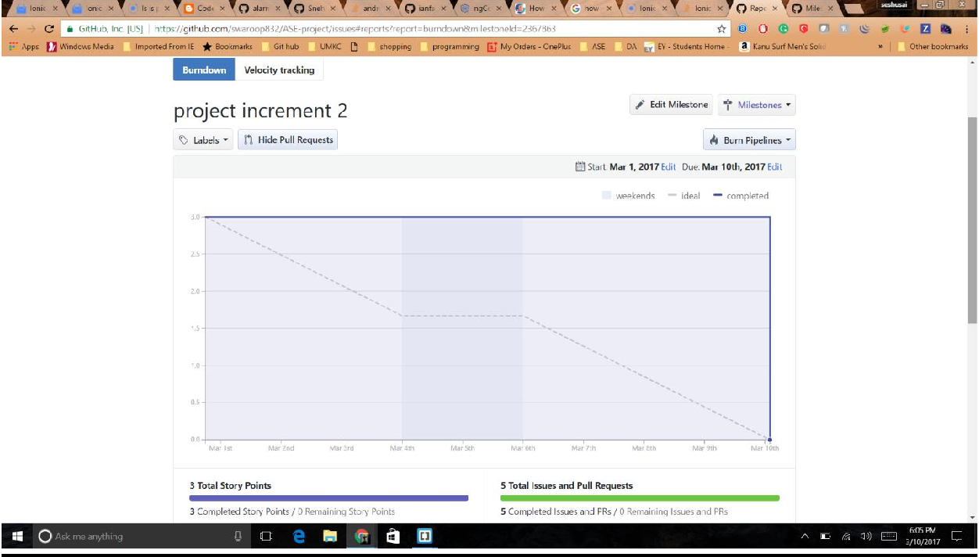

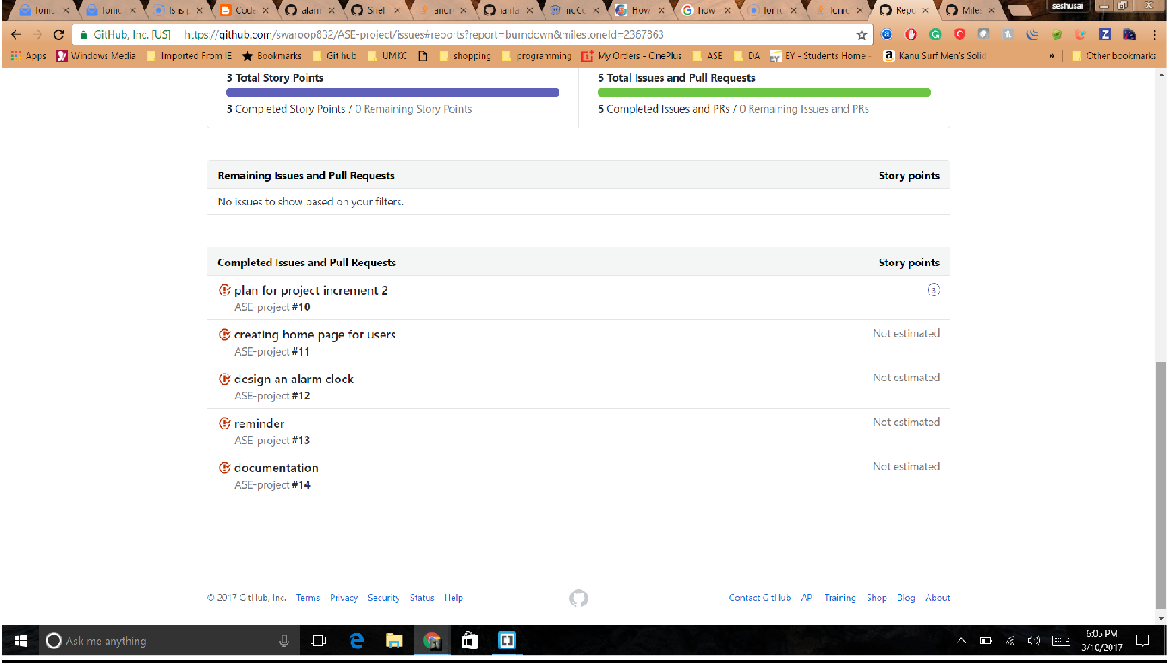

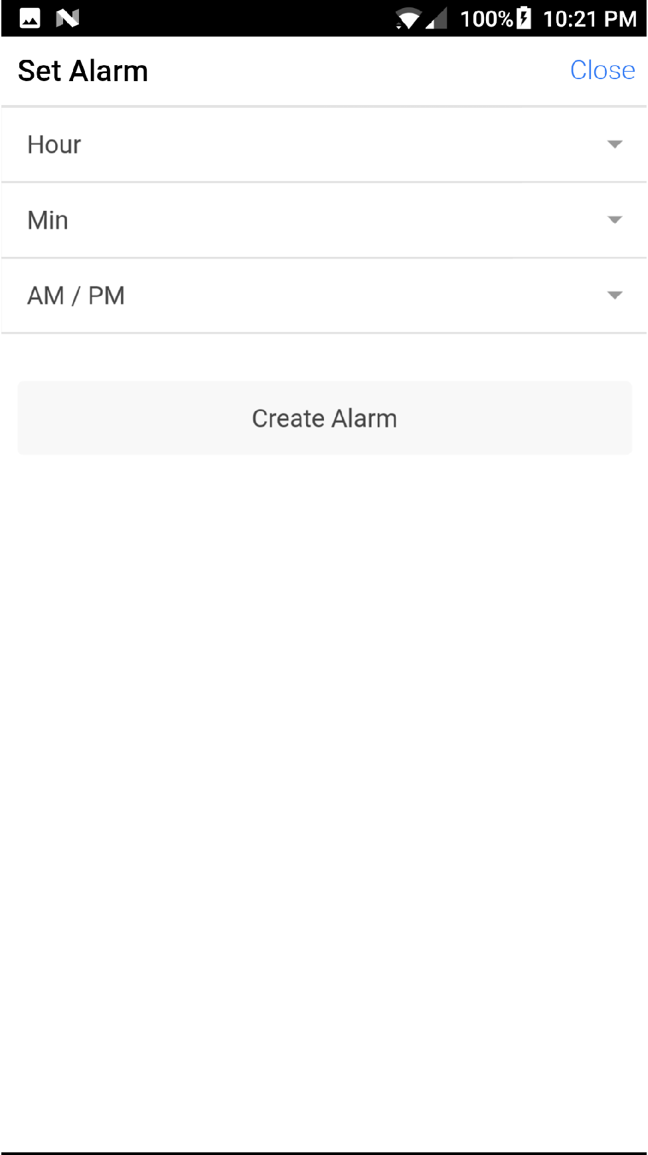

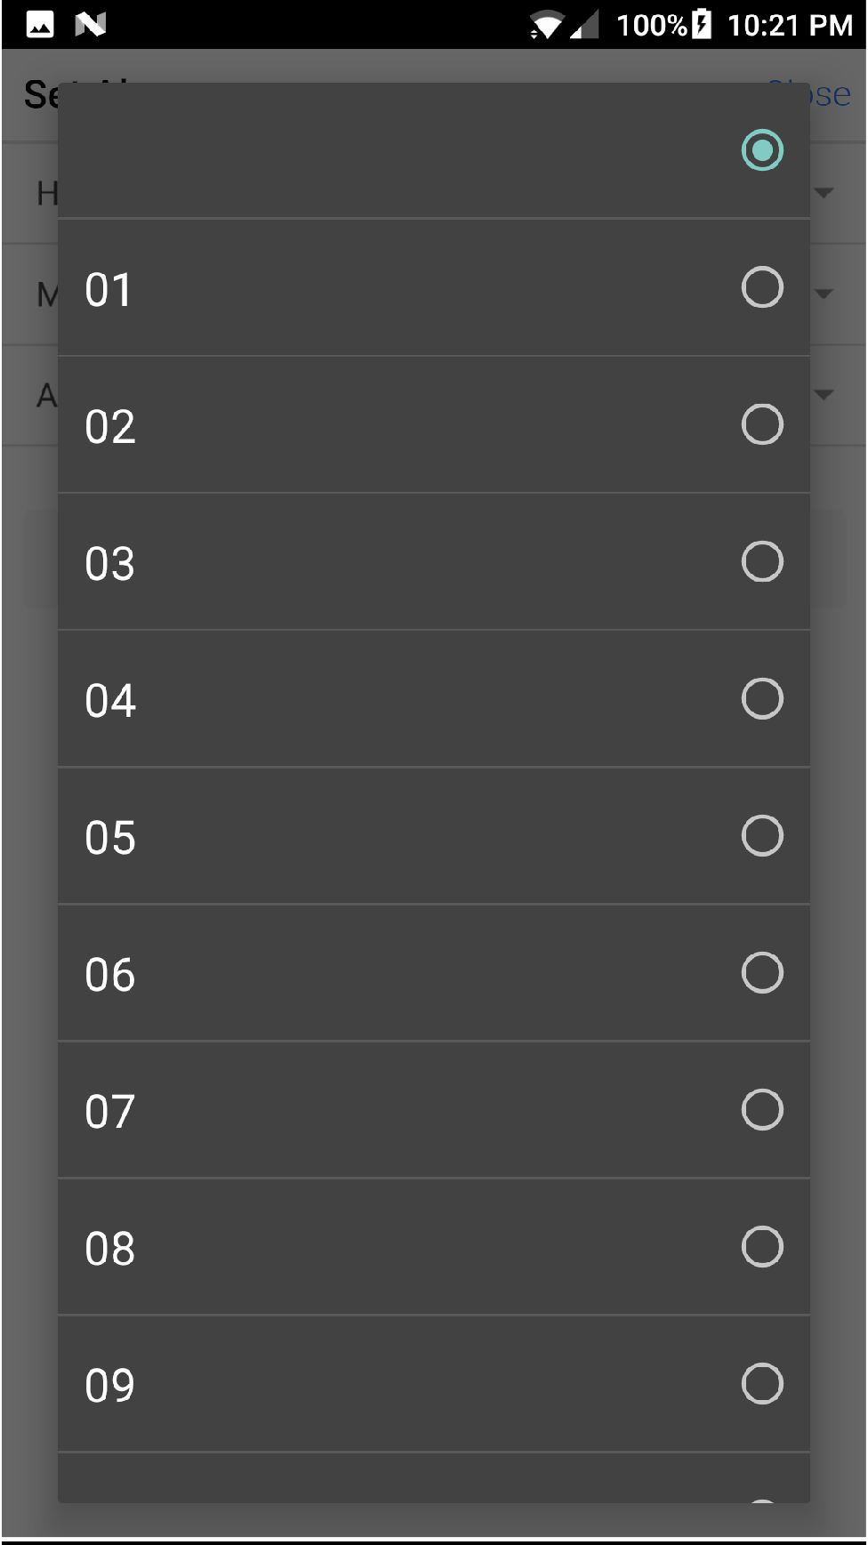

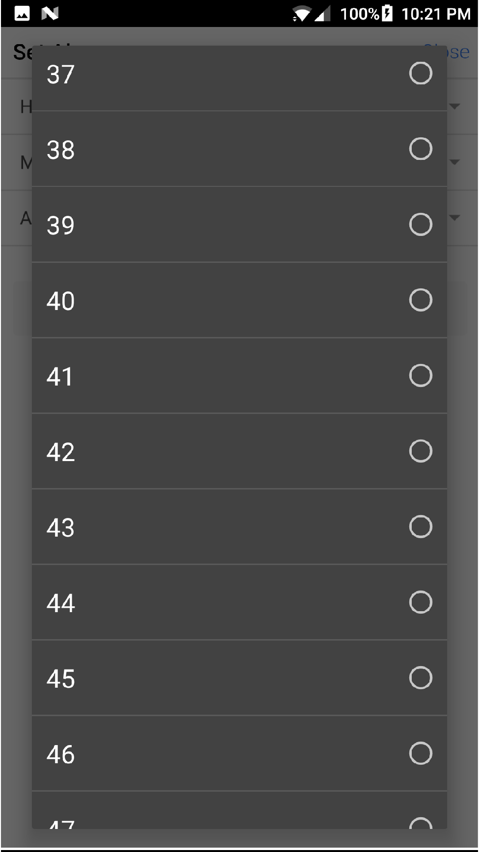

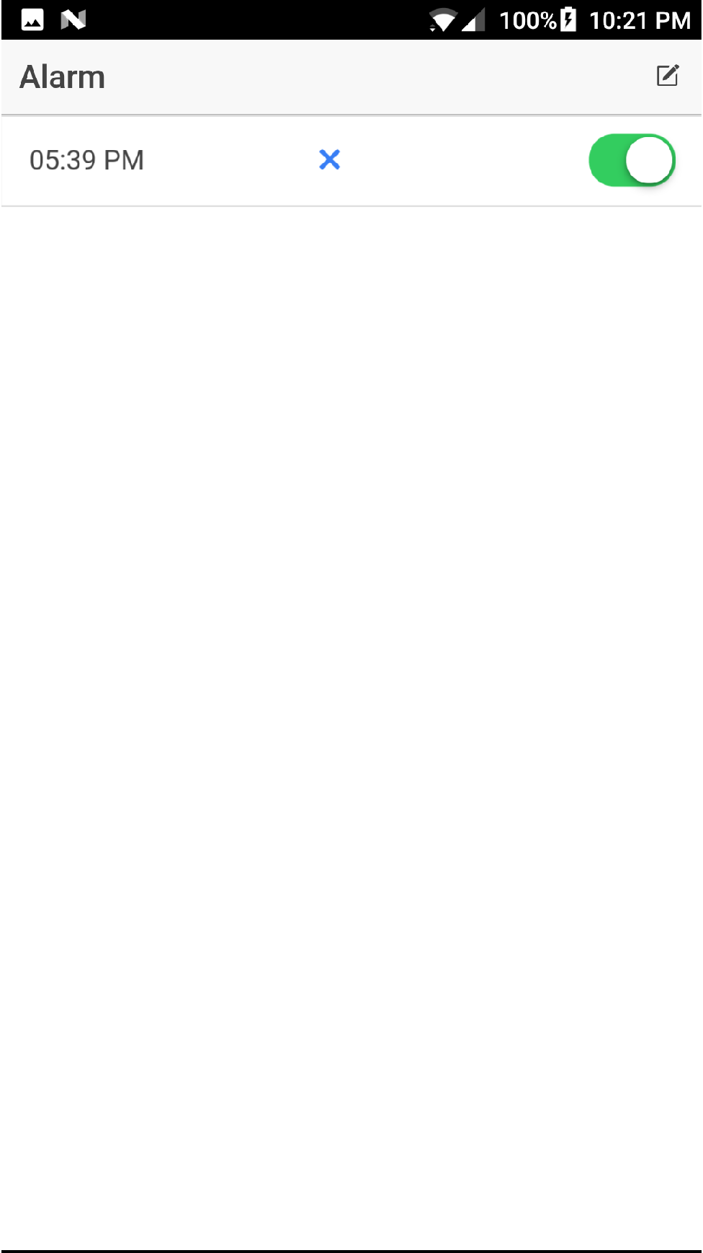

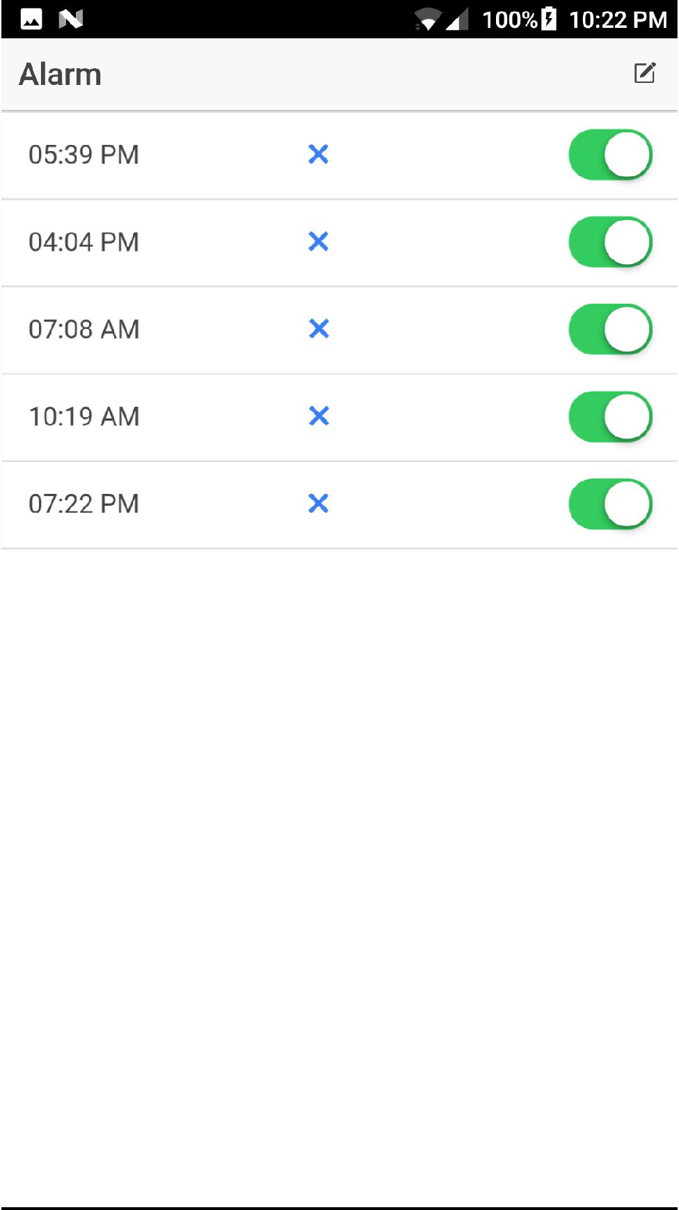

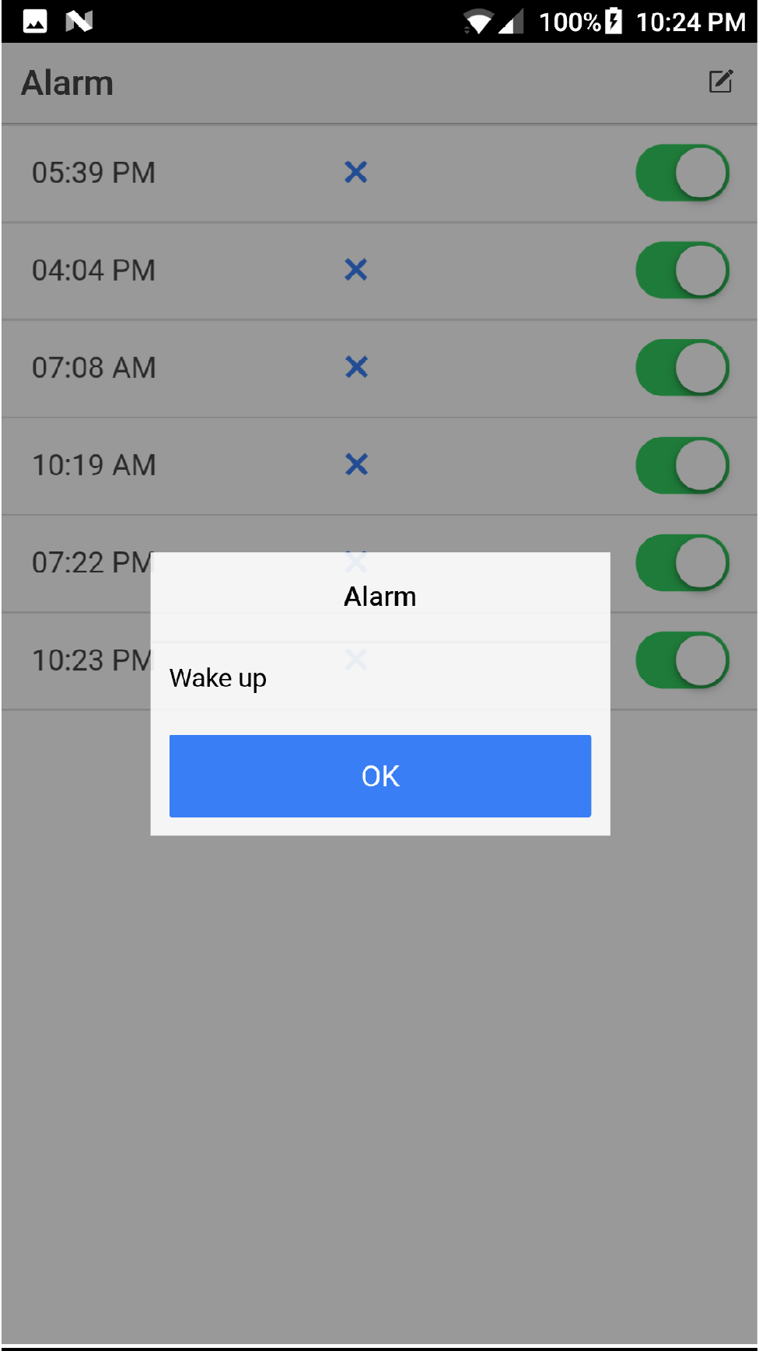

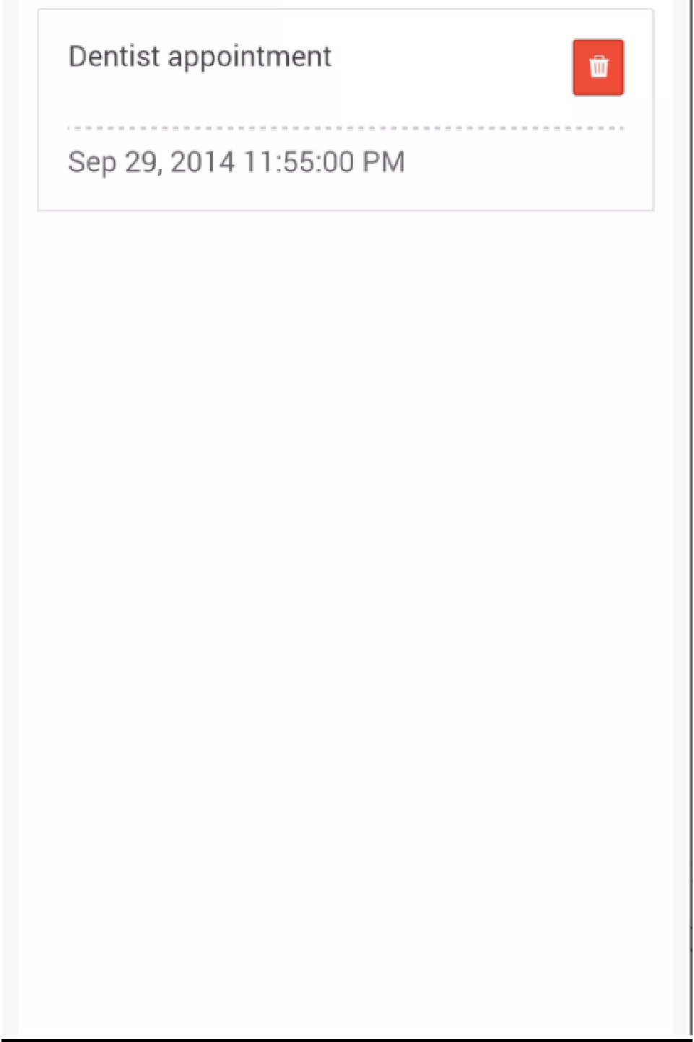

### Implementation status report

**Technologies Used:** Android SDK, HTML, CSS, JS, Angular JS, J2EE.

### Work Completed

* Design and Architecture of the Application
* Login and Registration using Android
* Implemented Alarm
* Implemented the application in Ionic platform
* Started working on Reminder page

**Work to be Completed**

* Improving the User Interface of the application.
* Collecting the API useful for the application.
* Should work on Reminder page and Notes page
* Improving User Interface of Alarm Page and enabling text to speech

**GitHub URL**: <https://github.com/swaroop832/ASE-project>

**Wiki Page:**

### Project Management

**Technologies we Used:** Ionic Framework, HTML, CSS, JS, Angular JS.

### Contributors:

* Srinivas Potluri – 25%
* Swaroop Chitiprolu– 25%
* Seshu Sai Prasanna Chennupati – 25%
* Sampath Boddeti – 25%

**7.Bibliography**

#### 1.<http://creately.com/>2.<http://developers.facebook.com/>

**Project increment 3**

### Increment Status Report: Work done:

* Modified the UI and made it more user collaborative
* Successfully embedded Reminder application
* Efficaciously embedded notes application
* Modified the login page so that user can also login using their google and Facebook accounts.
* Effectively entrenched puzzles into alarm app

Technologies used: Android SDK, HTML, CSS, JS, Angular JS, J2EE. GitHub URL: <https://github.com/swaroop832/ASE-project>

**Contributors:**

* Srinivas Potluri – 25%
* Swaroop Chitiprolu– 25%
* Seshu Sai Prasanna Chennupati – 25%
* Sampath Boddeti – 25%

**Issues that we faced and milestones:**

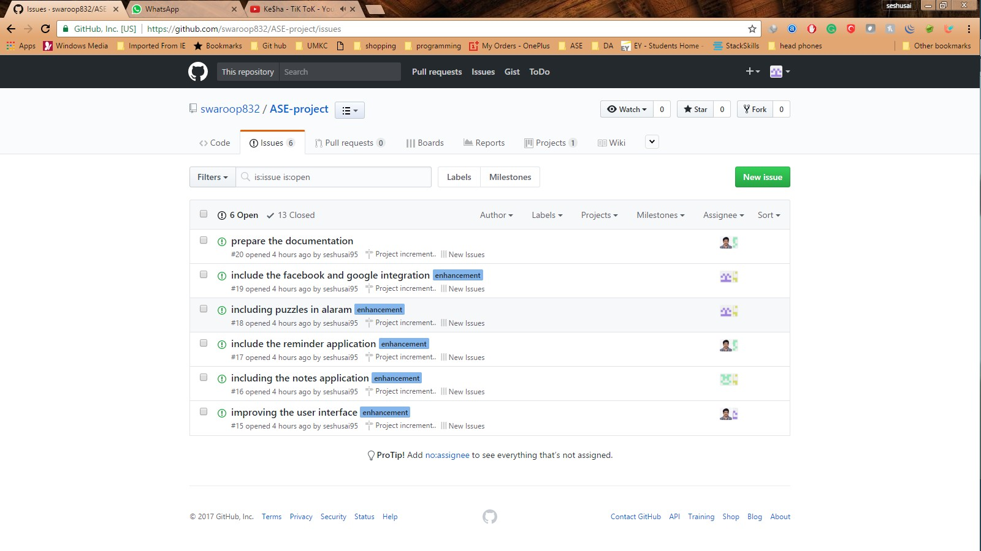

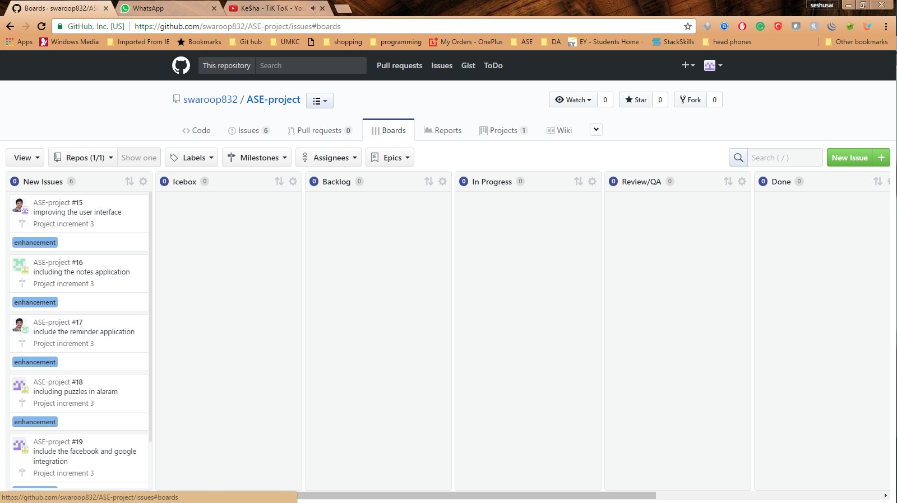



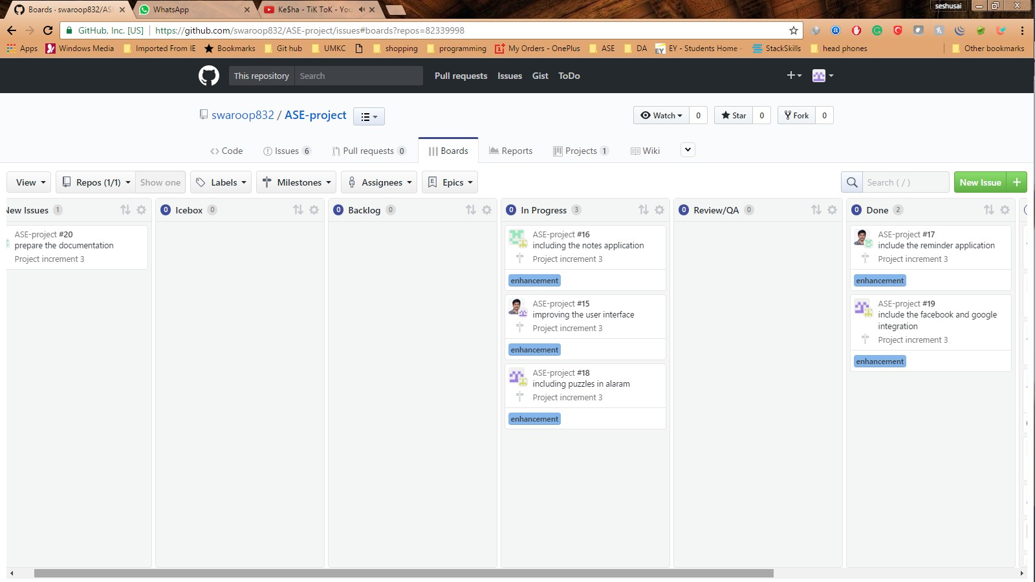

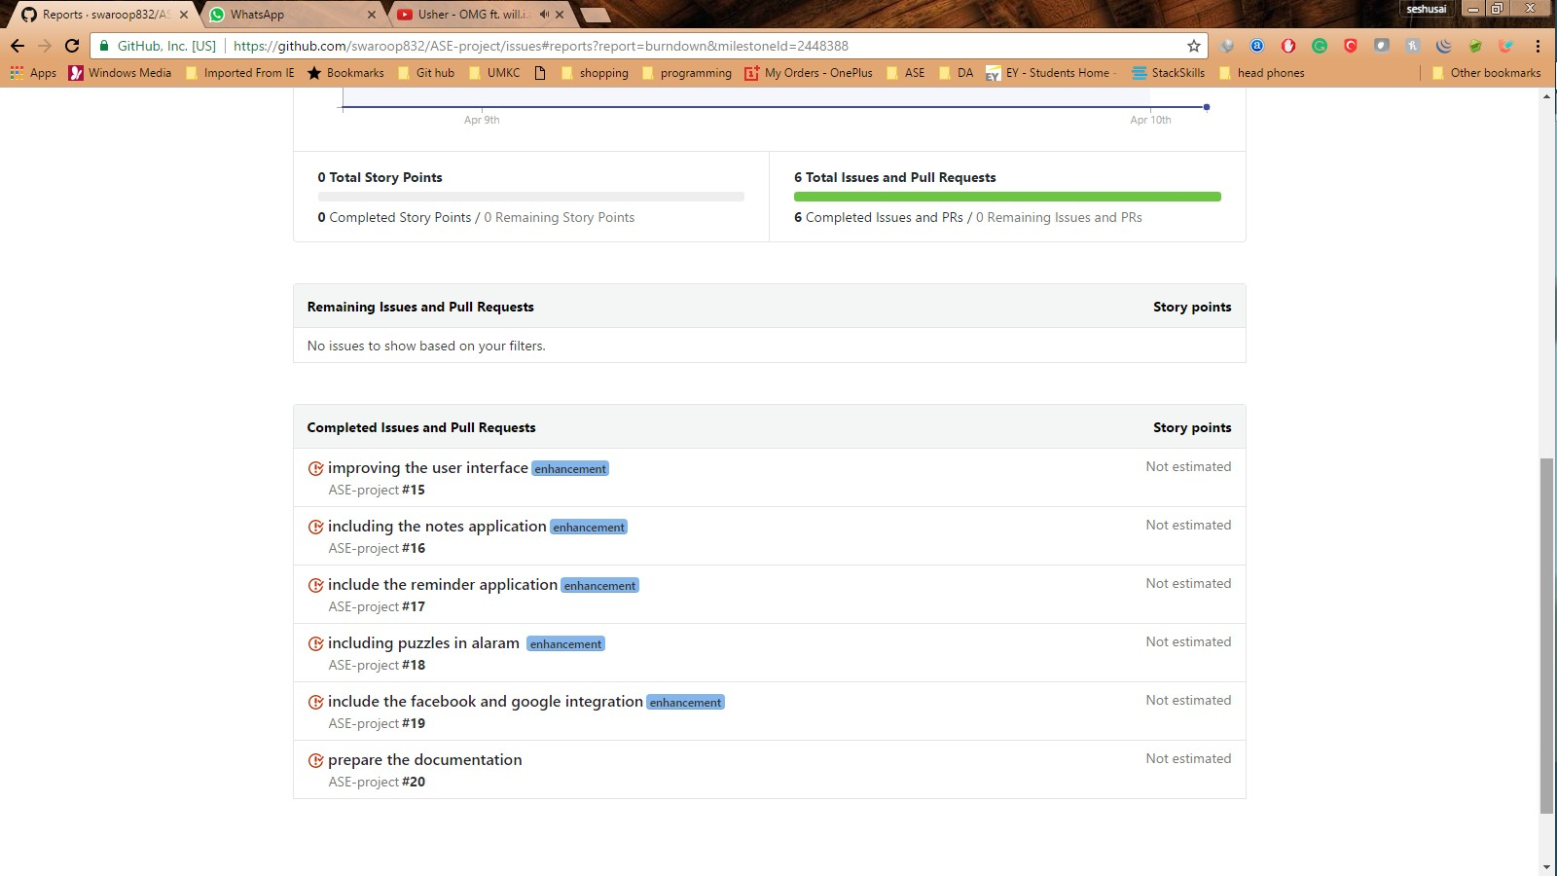

#### We improved the user interface and included some extra login features

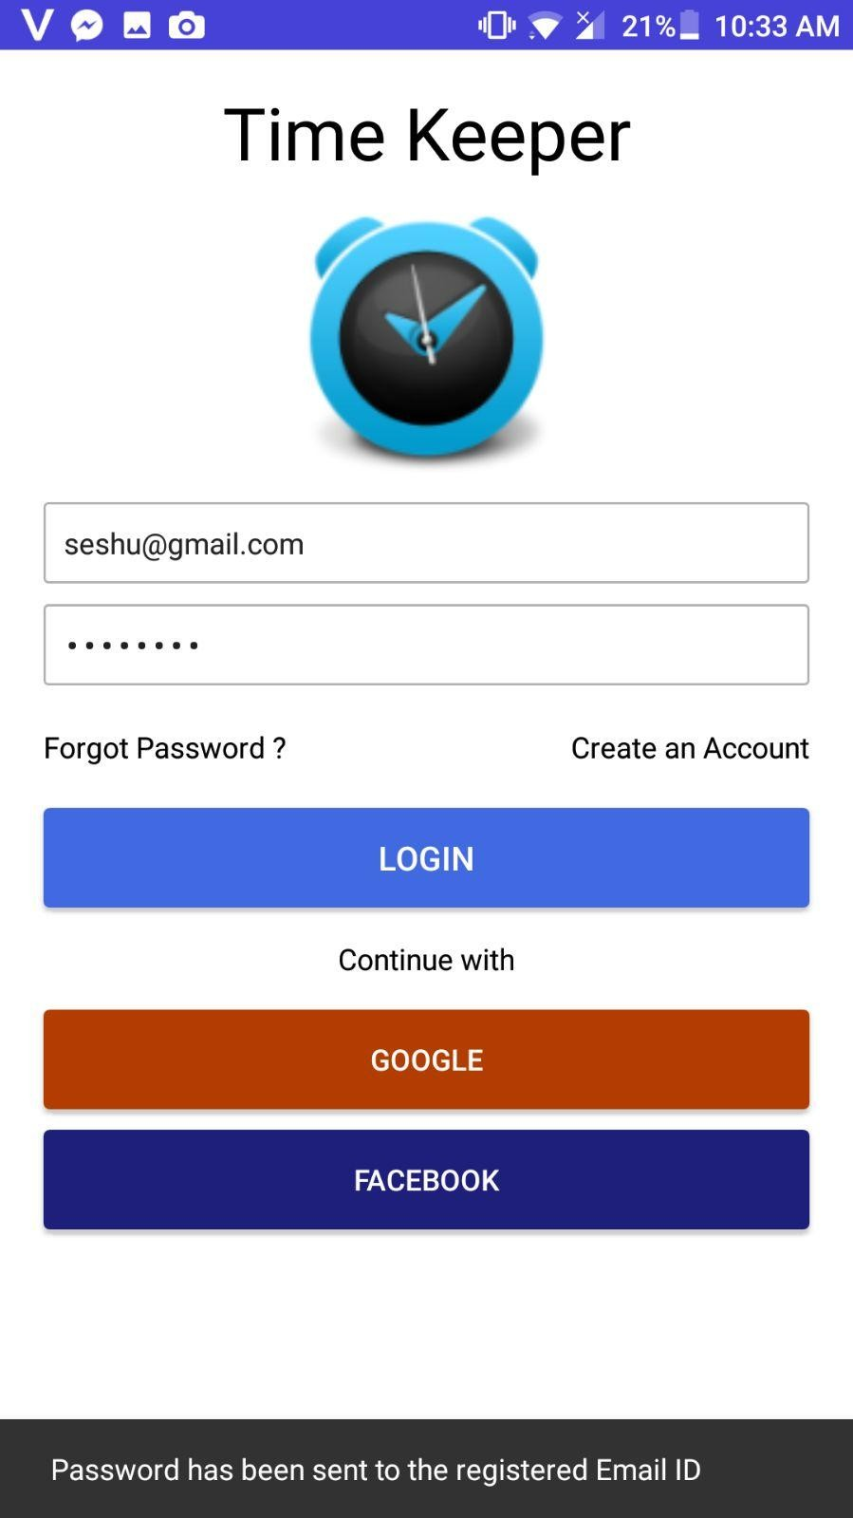

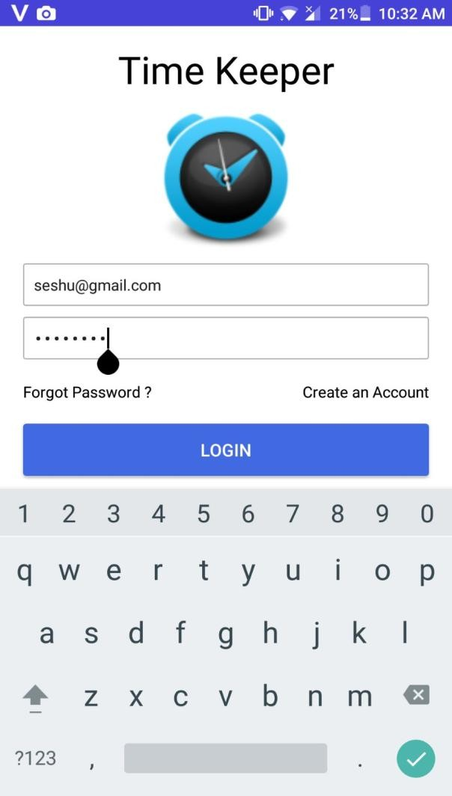 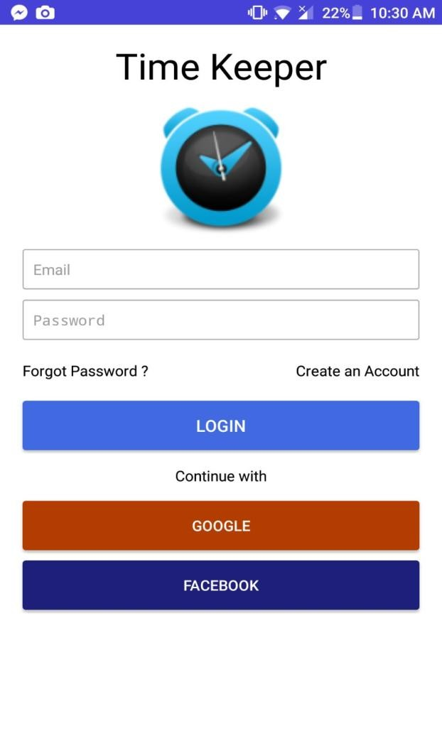

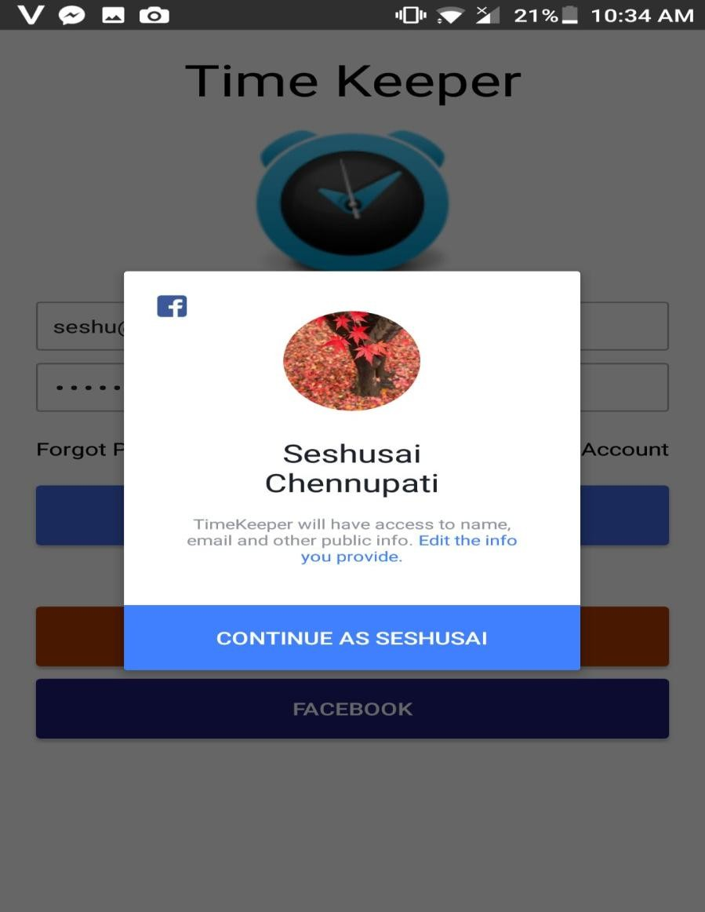 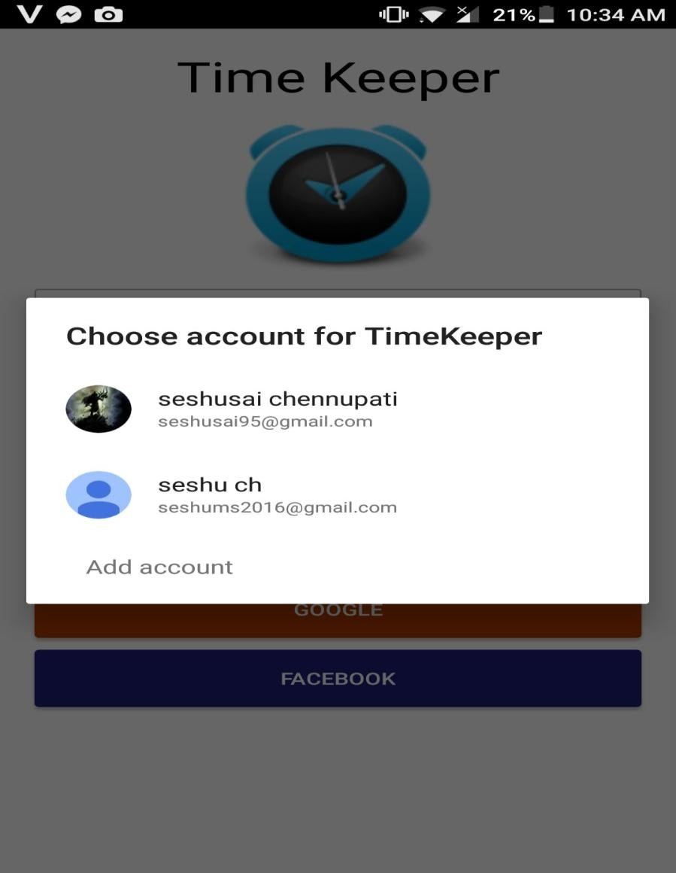

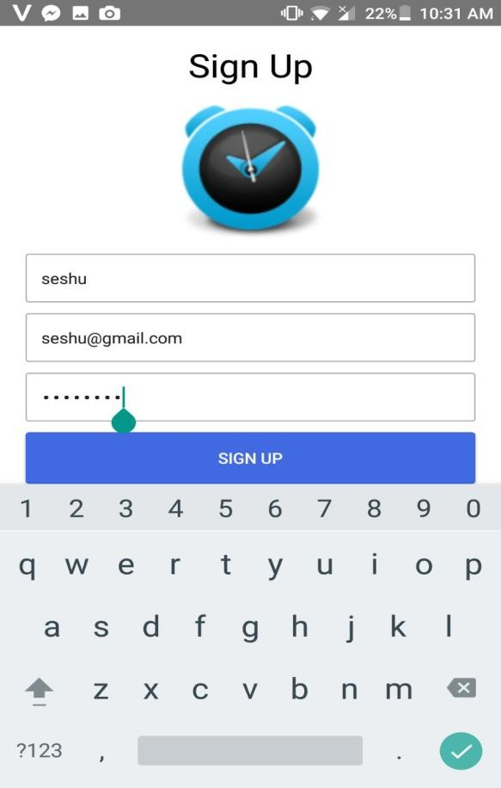 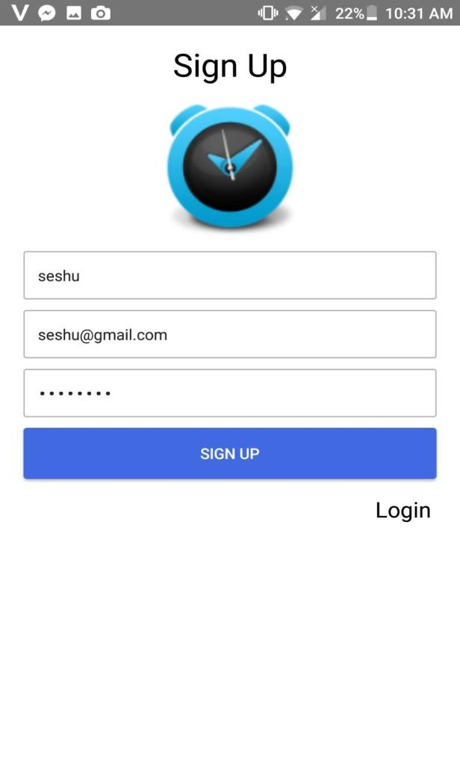

**We improvised the alarm features so that it is user intractable**

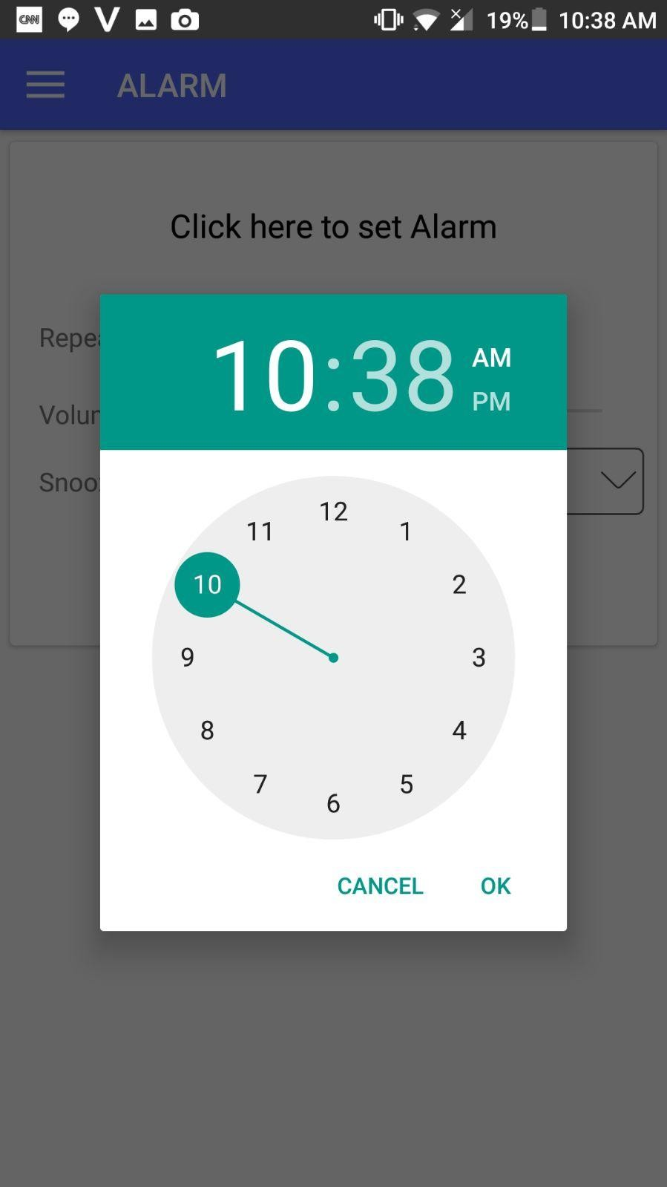

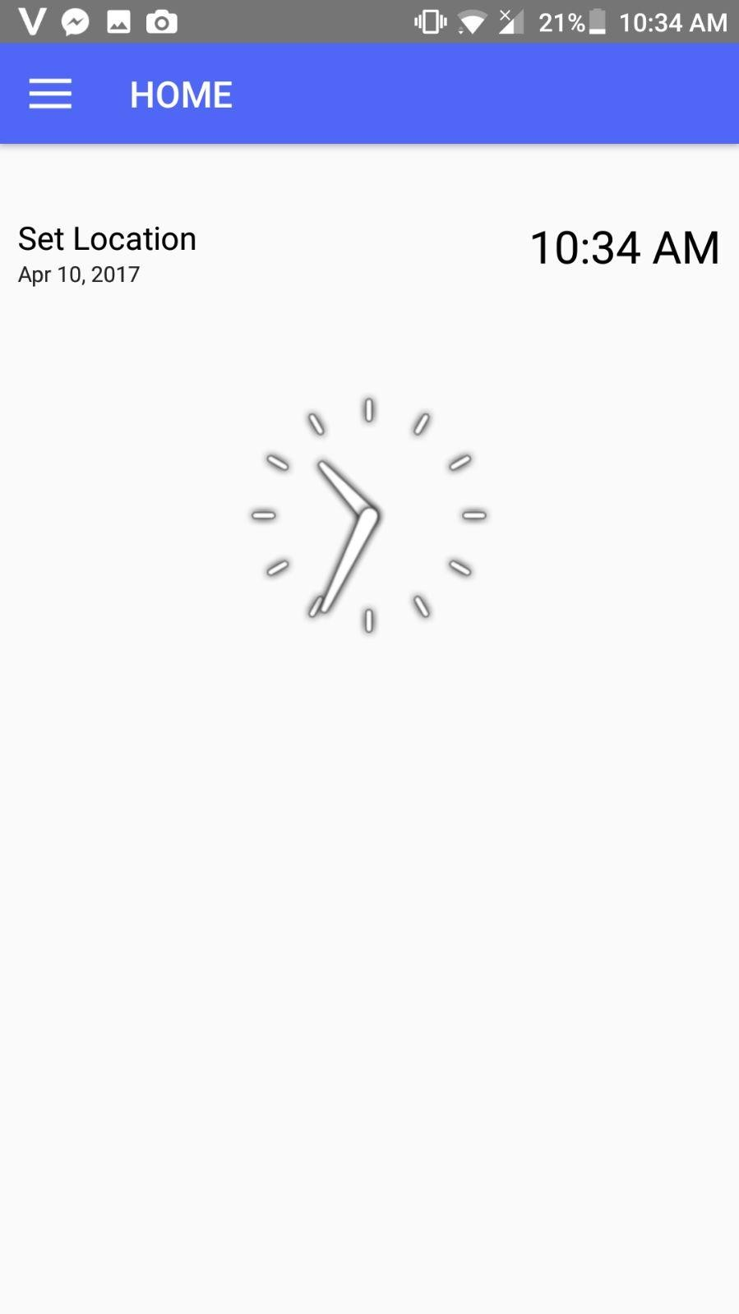

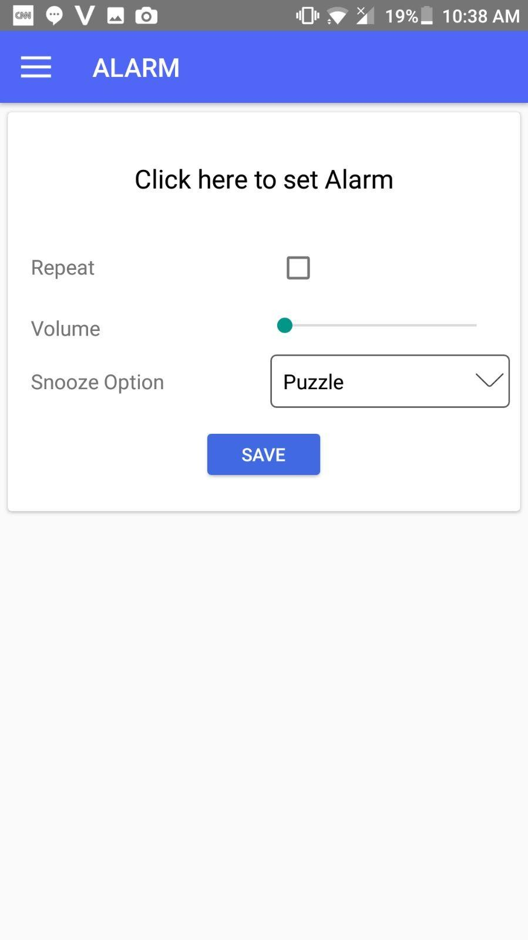

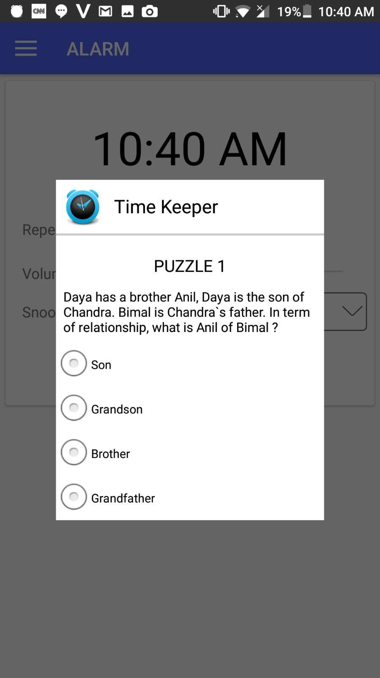

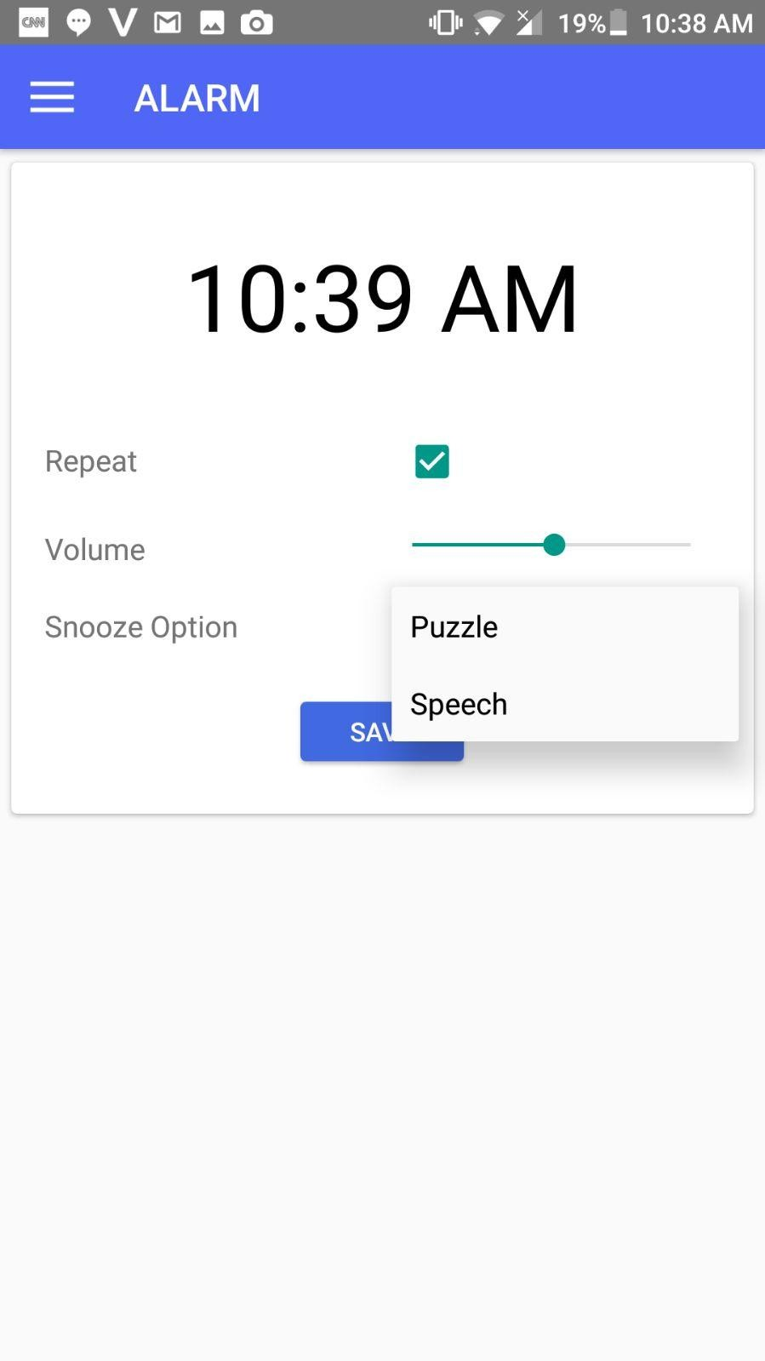

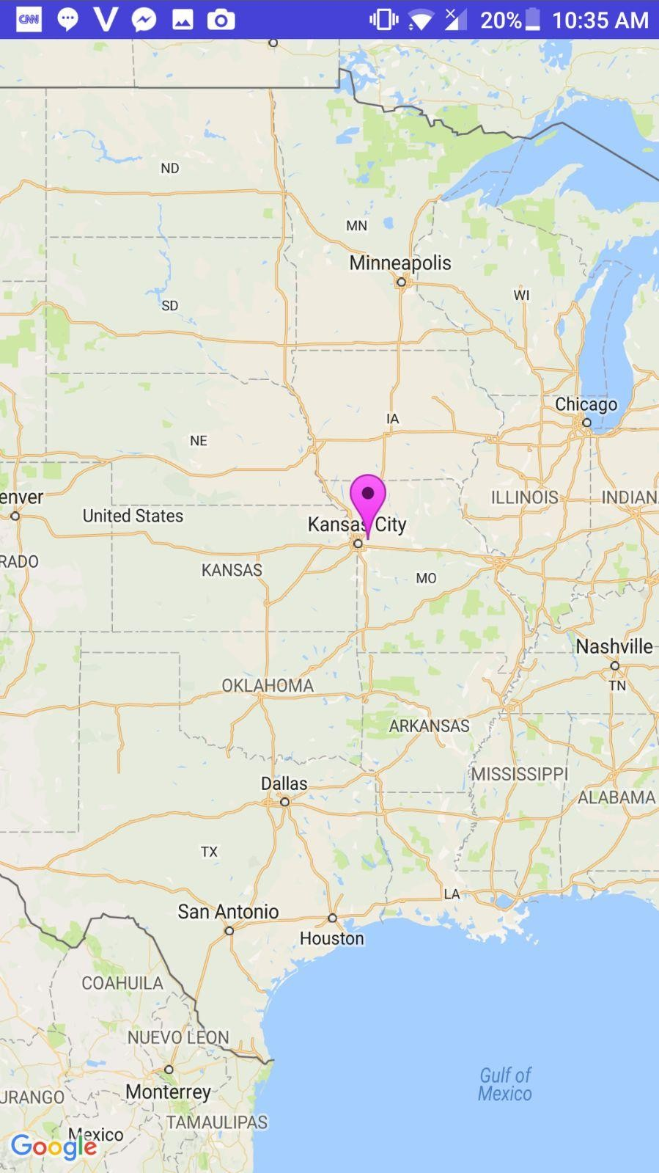

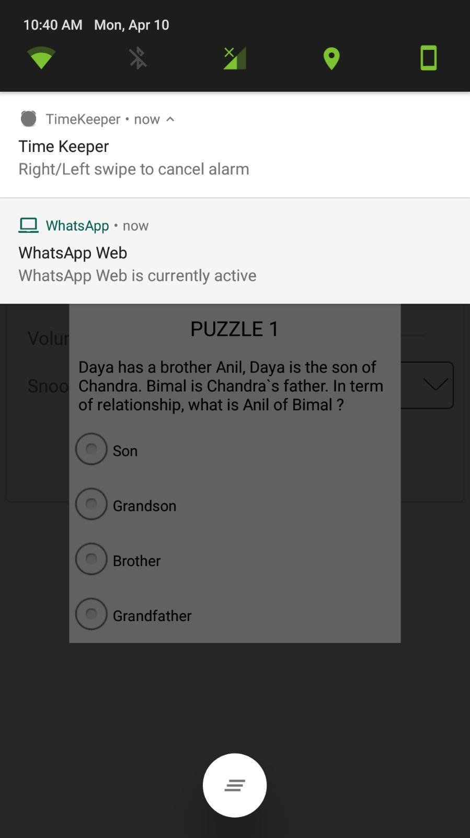

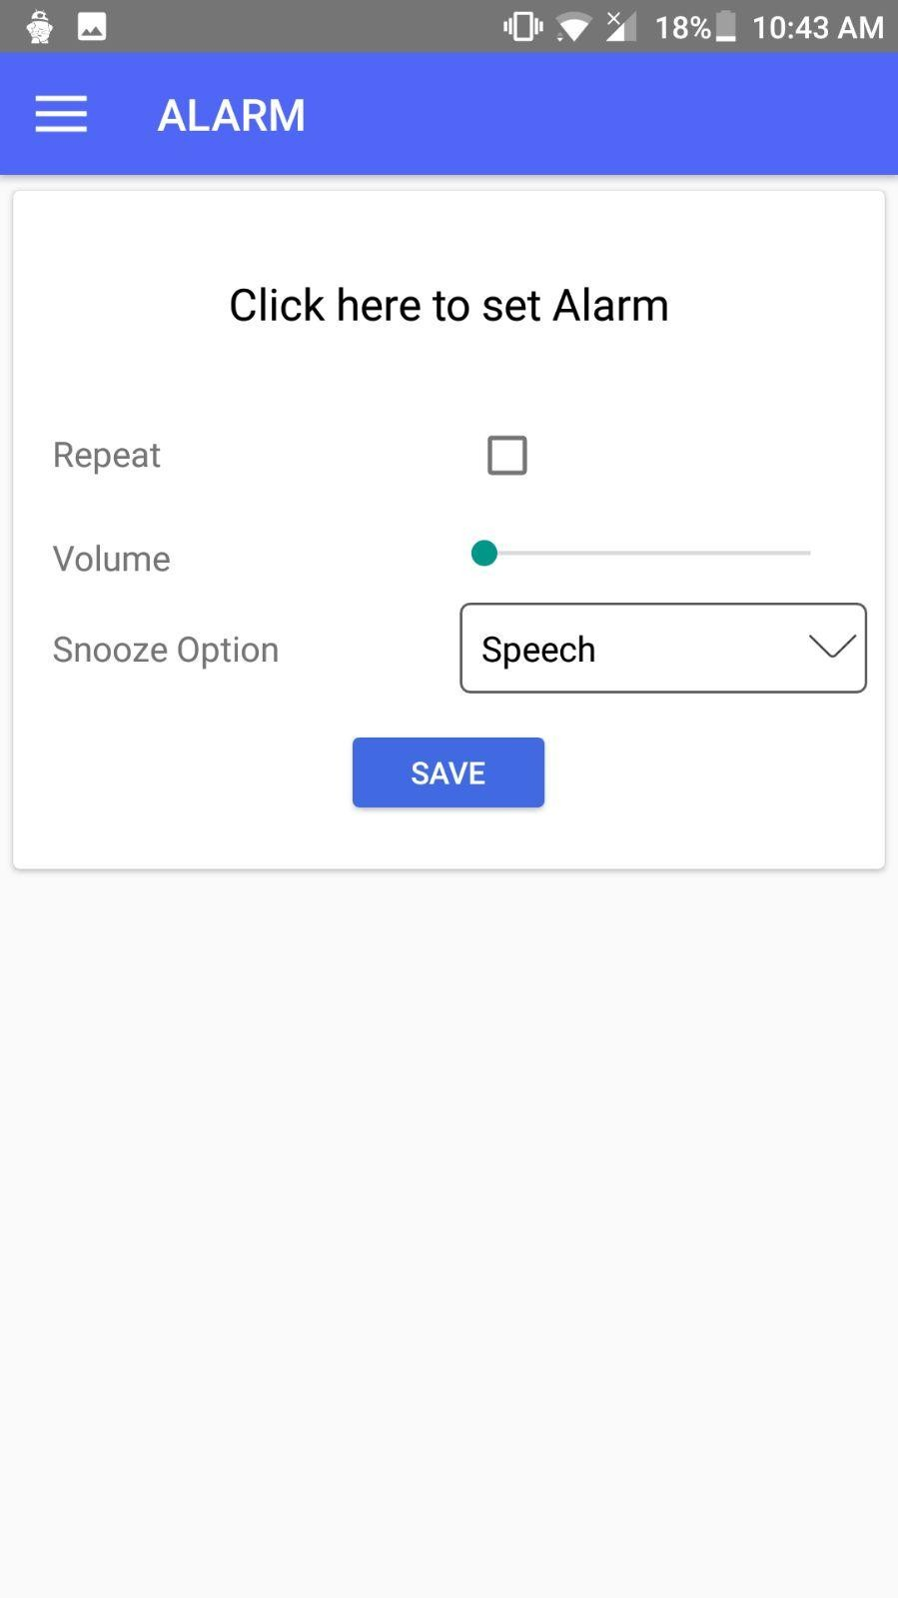

We embedded notes and reminder applications into our app

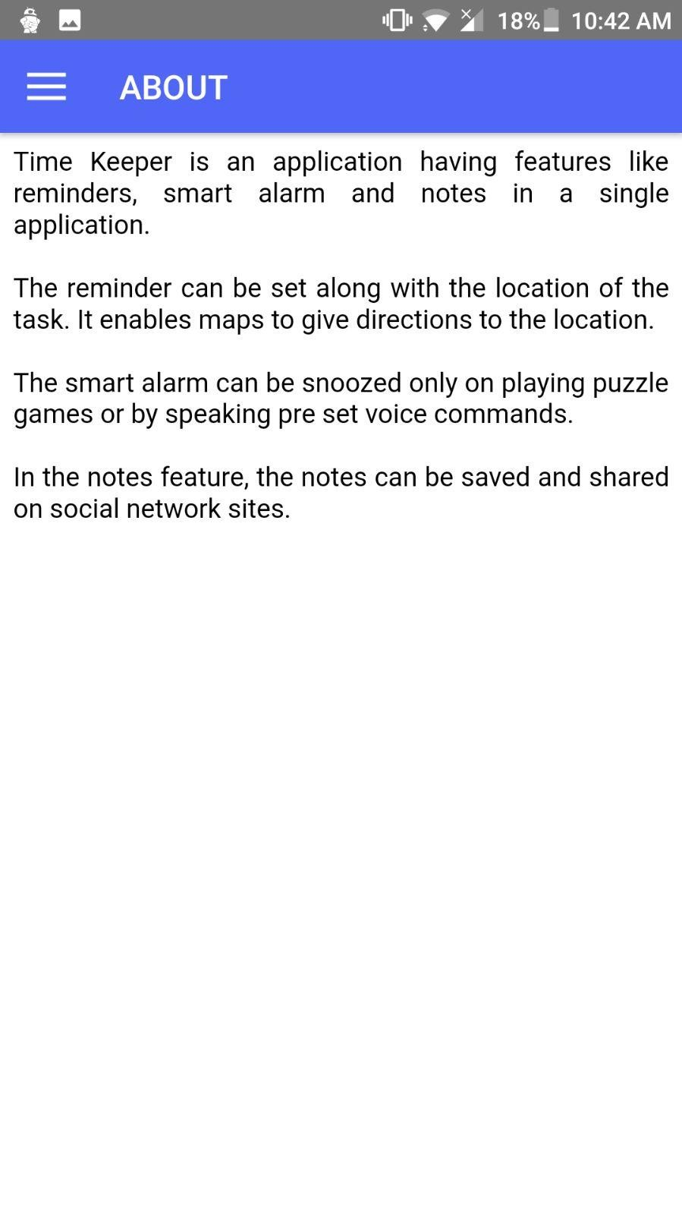

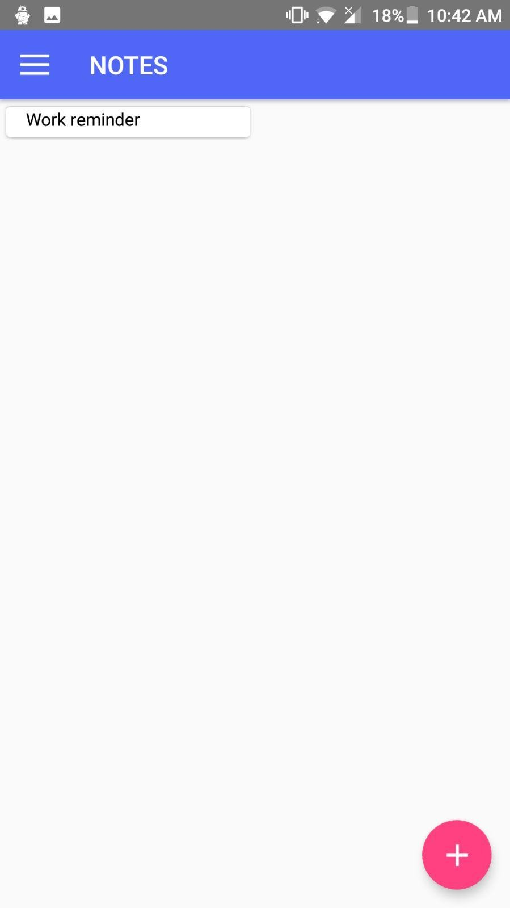

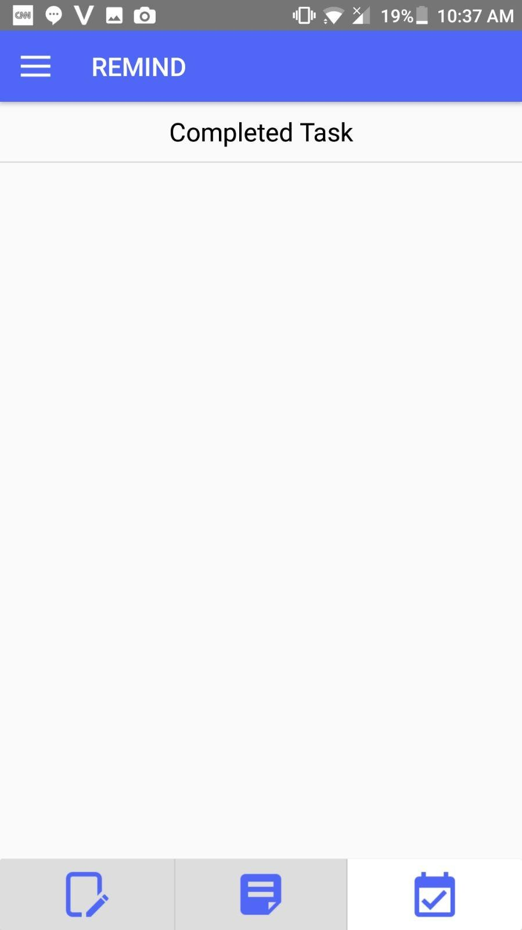

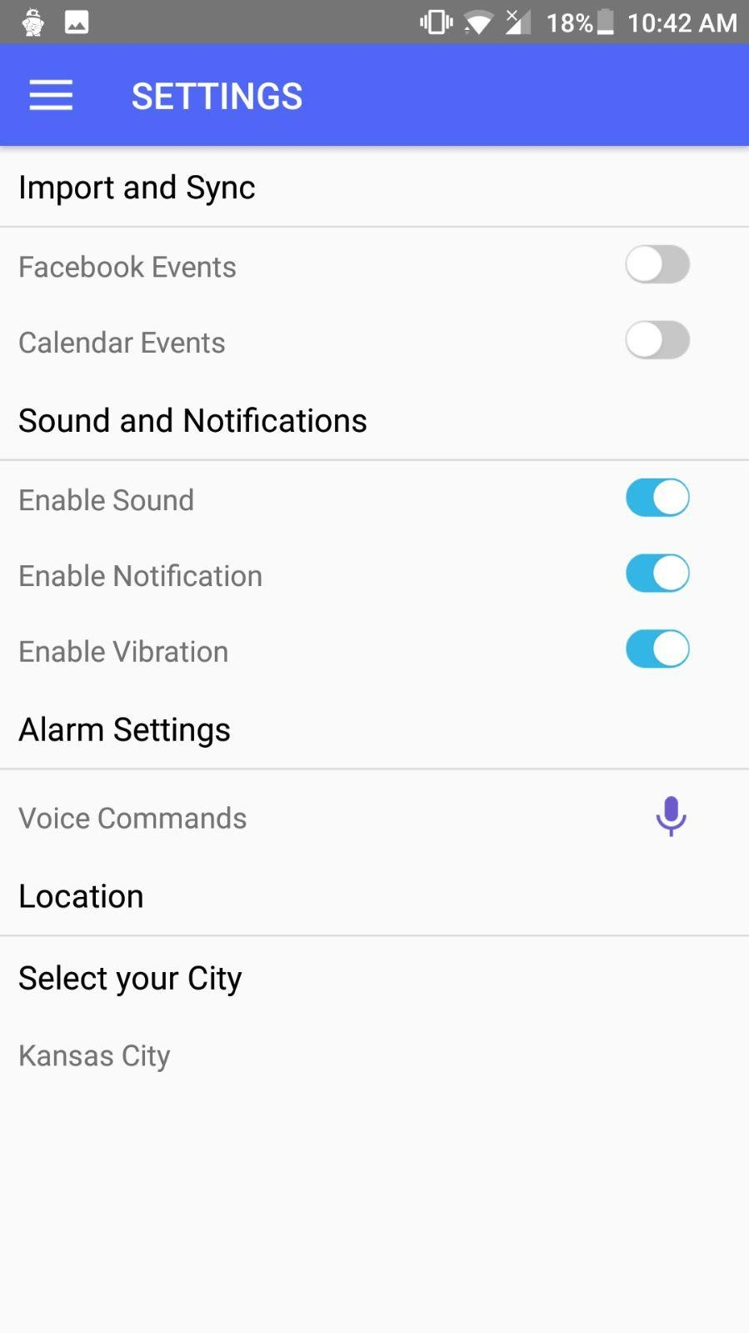

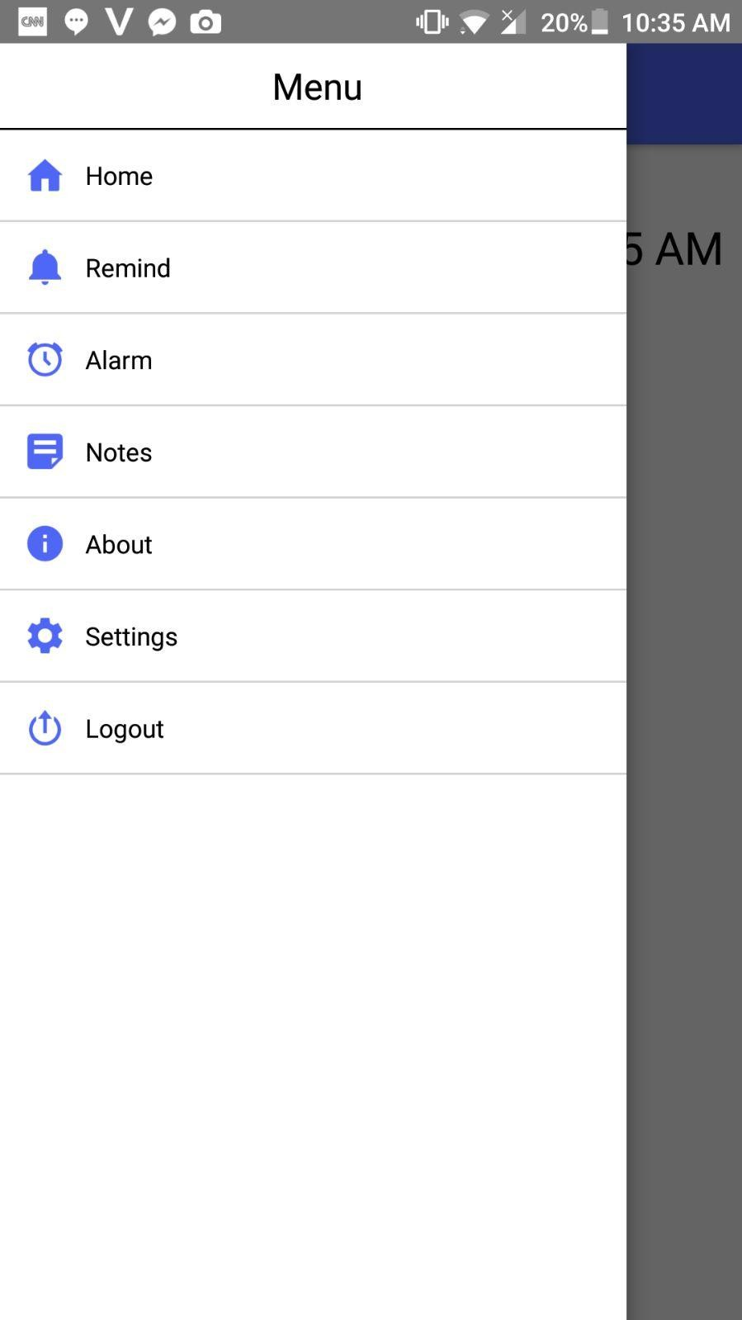

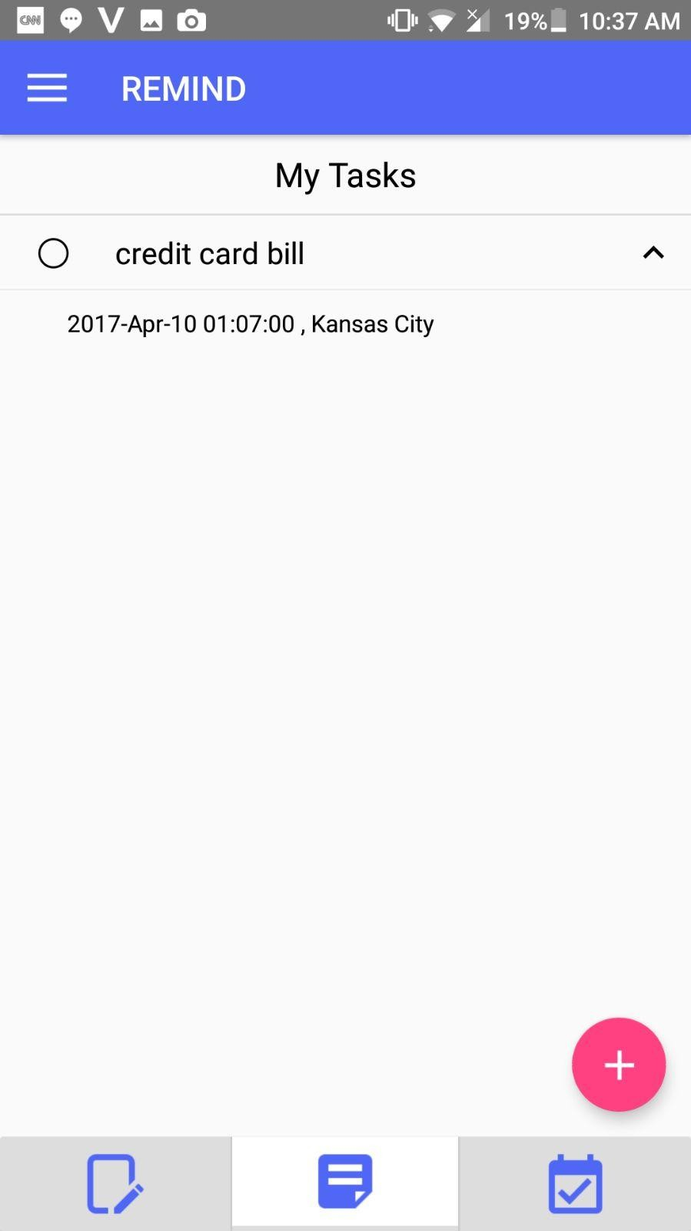

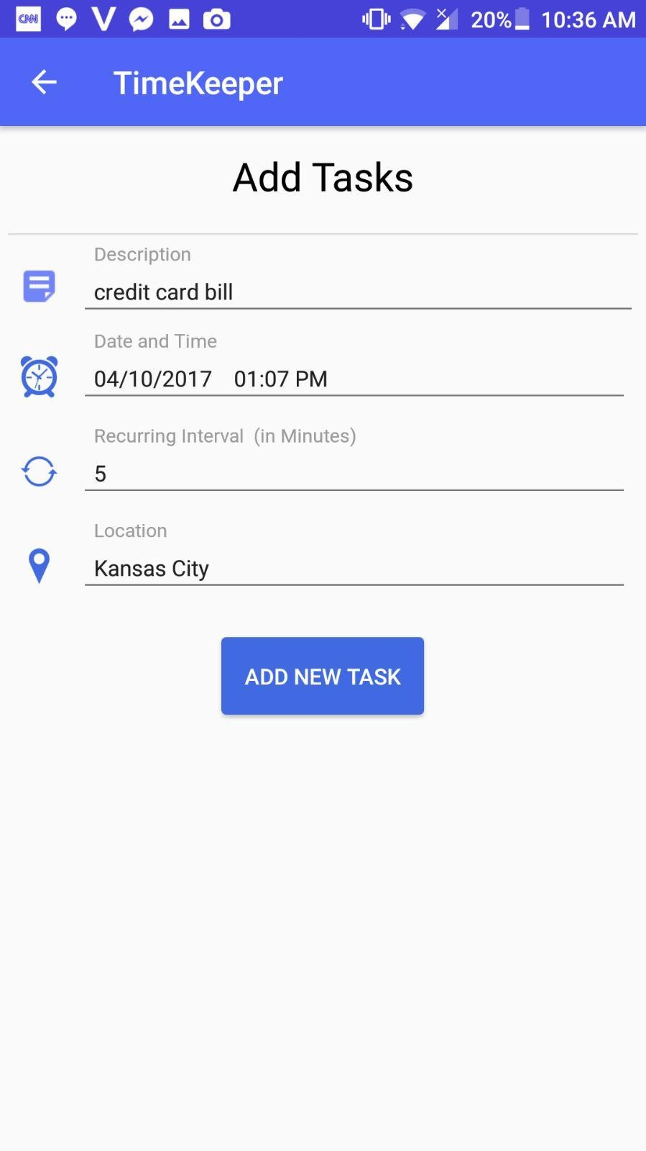

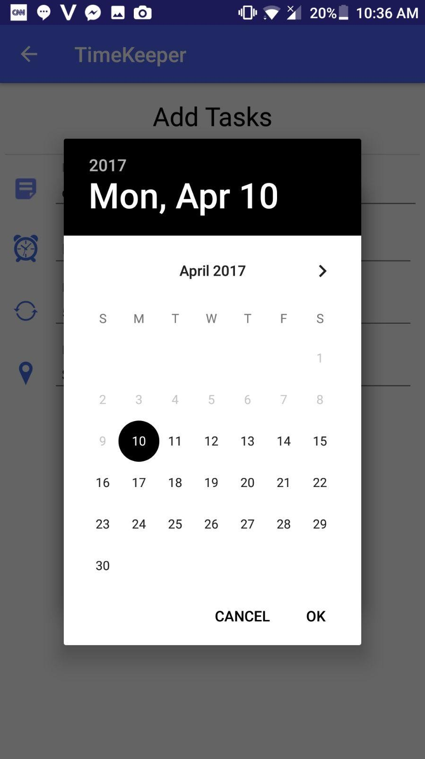

User stories:

|  |  |  |
| --- | --- | --- |
| **I am** | **It’s Tenacity.** | **Its Job** |
| **User.** | **Remind**  Set a Remainder using time and date and remind interval options. | Notifies the user about his reminders by popping up a message. |
| **Alarm** |  |
|  | Waking up user at |
| Sets the user desired | the exact time and |
| alarm using puzzles or | date he opted to |
| voice commands. | wake up. |
| **Notes** | Helping the user to |
| To take some | remind what he/she |
| important notes from | is supposed to be |
| user. | remembered. |

**Testing:**

**Cases for Login and signup pages**

|  |  |  |  |
| --- | --- | --- | --- |
| **Cases Types** | **Explanation for Test cases** | **Predictable Results** | **Unaffected Result** |
| Login | Please enter Invalid Username & Password | It is Error | It is Failure |
| Login | Enter Valid Username & Valid Password | Logged into Home Page | It is Success |
| Signup | Email ID should end with  @mail.com | Invalid Mail | It is Success |
| Signup | Password column and Confirm Password column should match | Registers shall be Directed to Login Page | It is Success |
| Alarm | Please enter a date, time and type of alarm desired | Alarm will ring when time comes. | It is Success |
| Reminder | Please enter a reminder, date and time when you need to be reminded. | A message pops up showing the reminder. | It is success |
| Notes | Please enter some notes which you couldn’t remember. | You can share this notes with any of your Facebook and whatsapp friends. | It is success. |

Things to work on by next increment

* + Should work on voice commands
  + Should work on changing the time zones successfully
  + Should work on trying to make app accessible through web interface

### Contributors:

* Srinivas Potluri – 25%
* Swaroop Chitiprolu– 25%
* Seshu Sai Prasanna Chennupati – 25%
* Sampath Boddeti – 25%

**7.Bibliography**

#### 1.<http://creately.com/>2.<http://developers.facebook.com/>

3. <http://developers.google.com/>

**PROJECT INCREMENT- 4**

**Work done:**

* Improved the efficiency of the application
* Increased the responsiveness of the application when being used by the user and made sure that there is no lag in the application
* Embedded voice commands into the application which can be used by the user to stop the alarm

**Technologies used:** Android SDK, HTML, CSS, JS, Angular JS, J2EE. **GitHub URL:** <https://github.com/swaroop832/ASE-project>

**Issues and milestones**

We faced some issues while implementing the voice commands. We faced some issues while imbedding the notes into the application. We had some tough time while improving the user interface of the application.

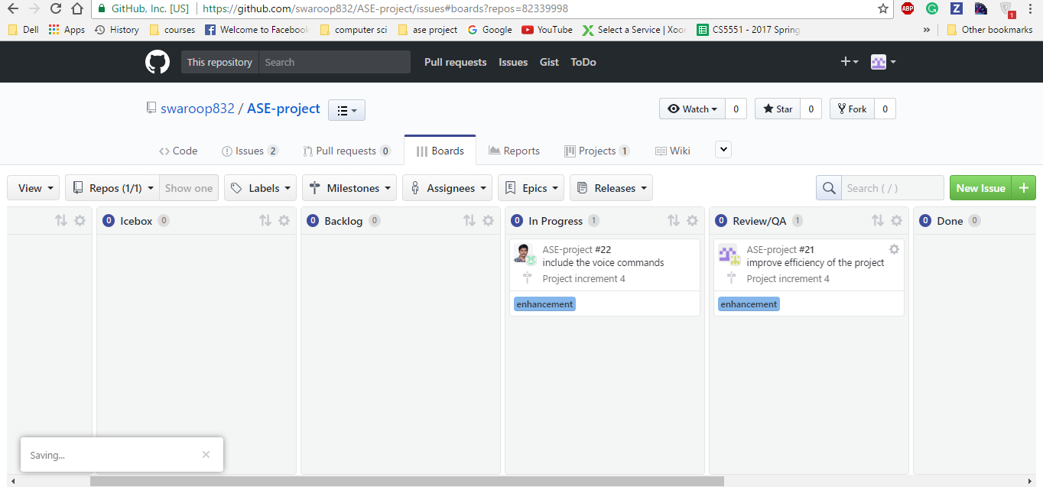

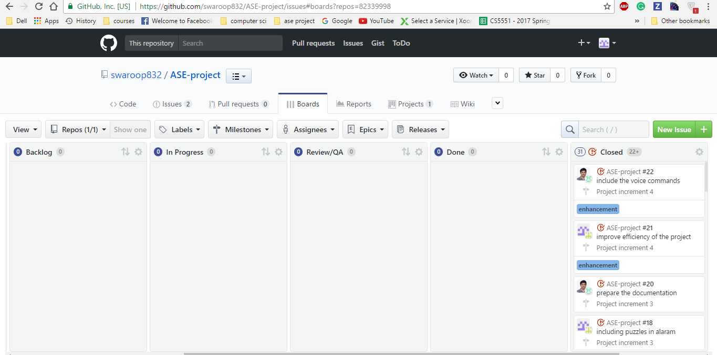

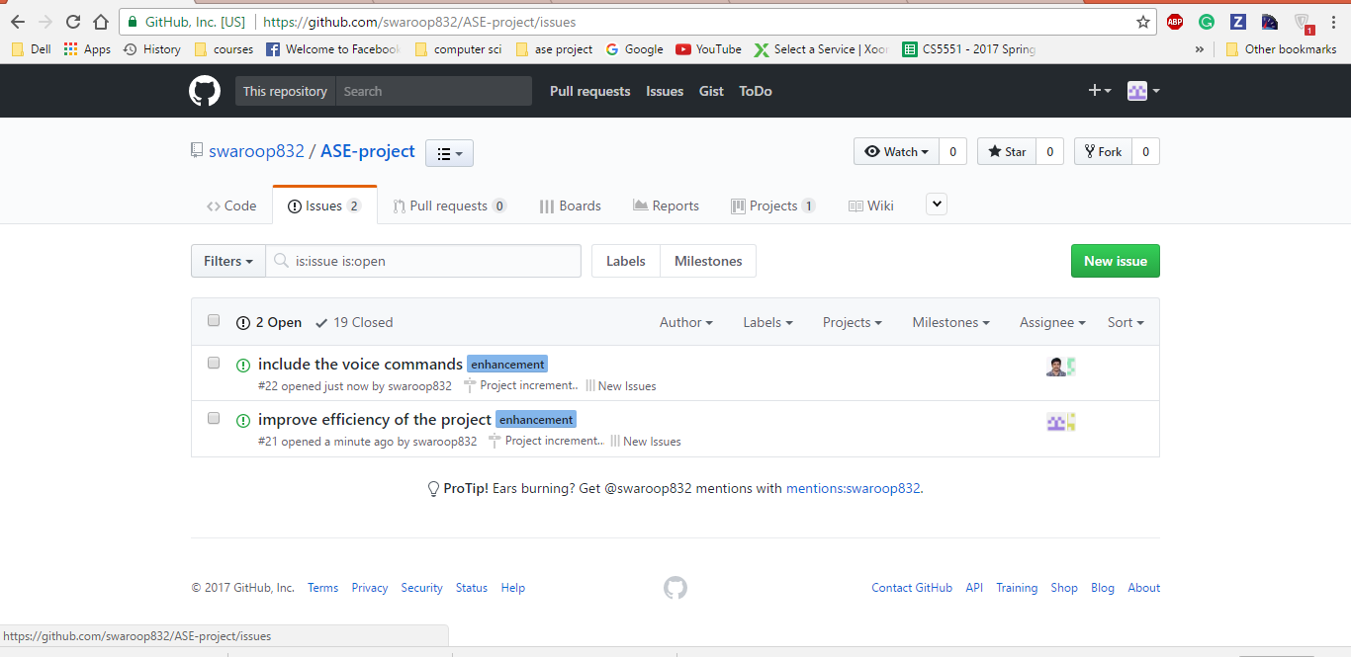

**Improvements we made in the application**

Imbedded different time zones in the app: A user can the time zone he wants to be displayed in the home screen.

In the below screenshot we can see different time zones, a user can select any time zone he desires.

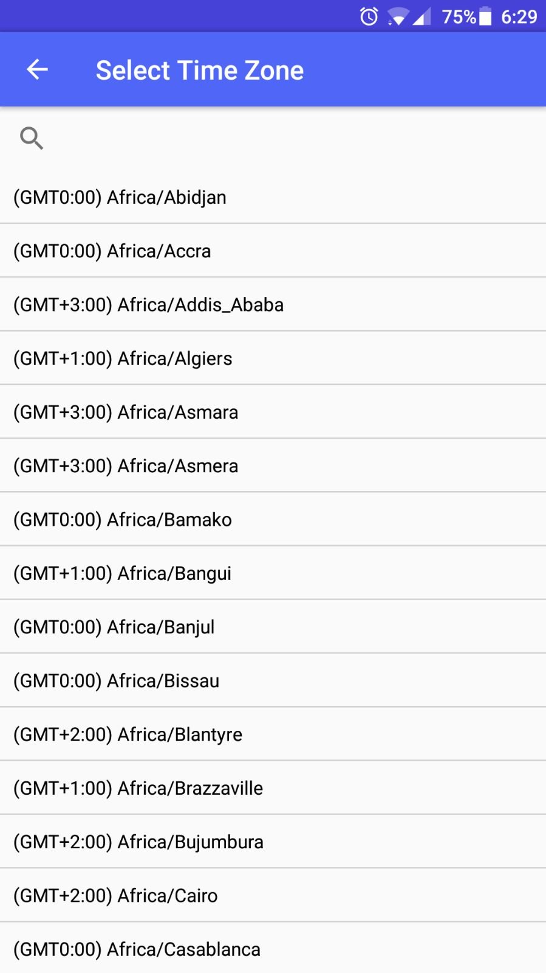

The below screen shot shows the home screen in the application once we login. It has a clock date and timezone.

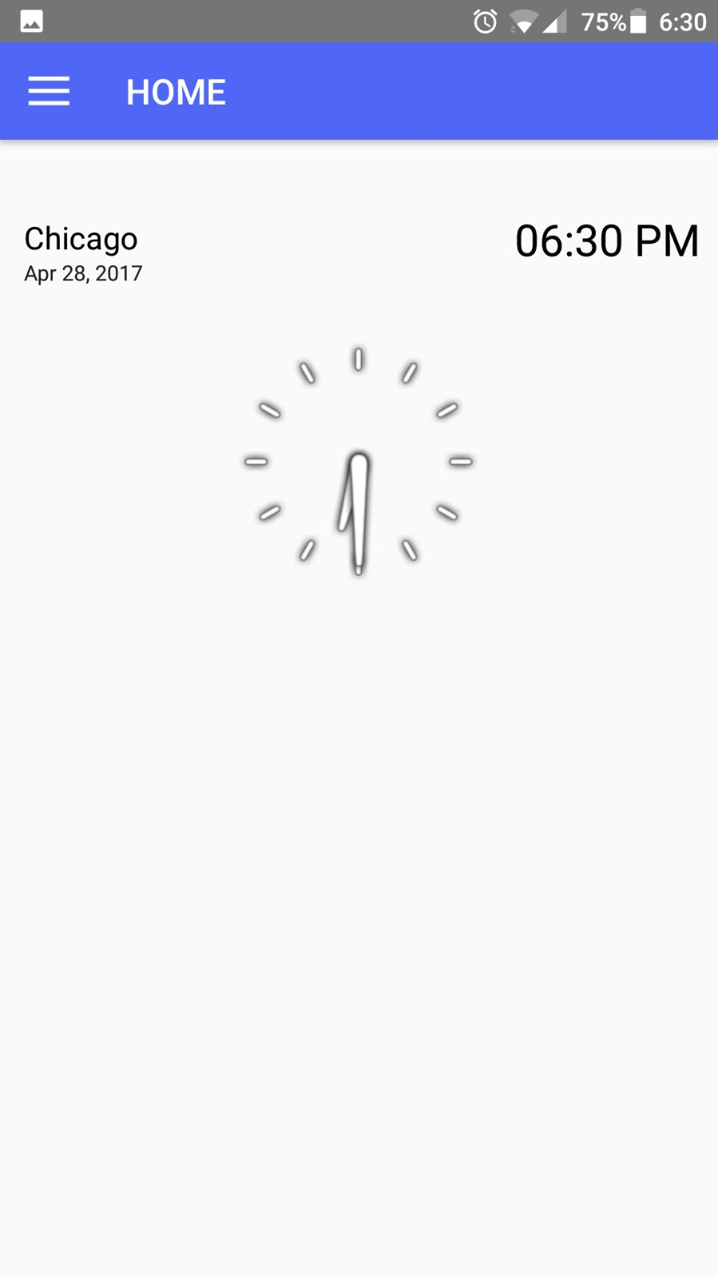

Included settings like import and sync, enabling sound and notifications,

including voice commands, showing your location.

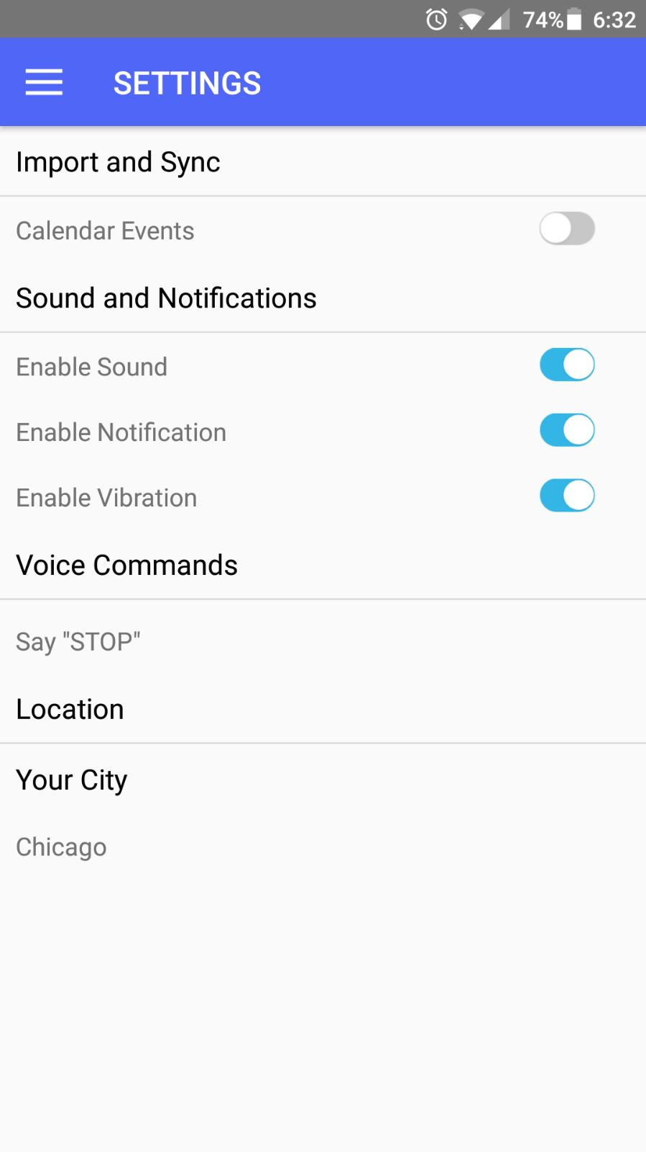

Imbedded voice commands into the application where user can stop the alarm by just saying the command like **stop.**



We used google API to implement voice commands into the app.

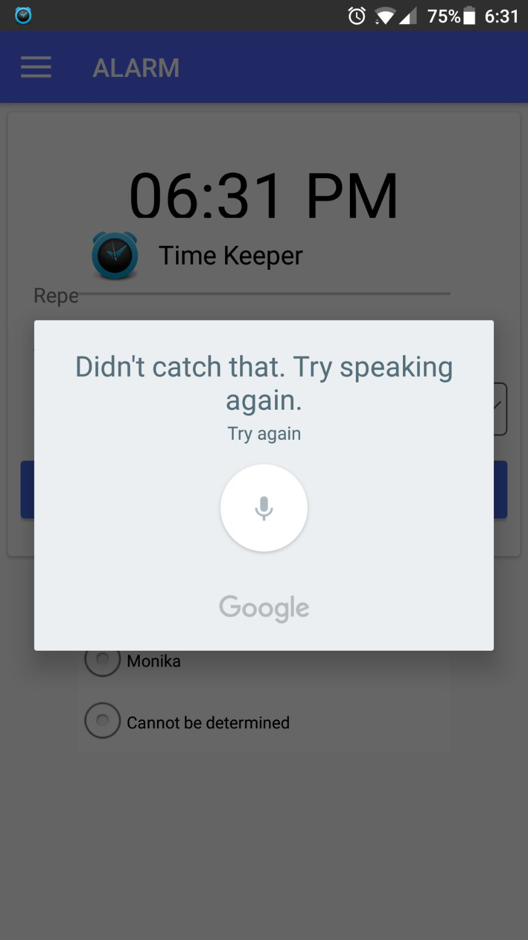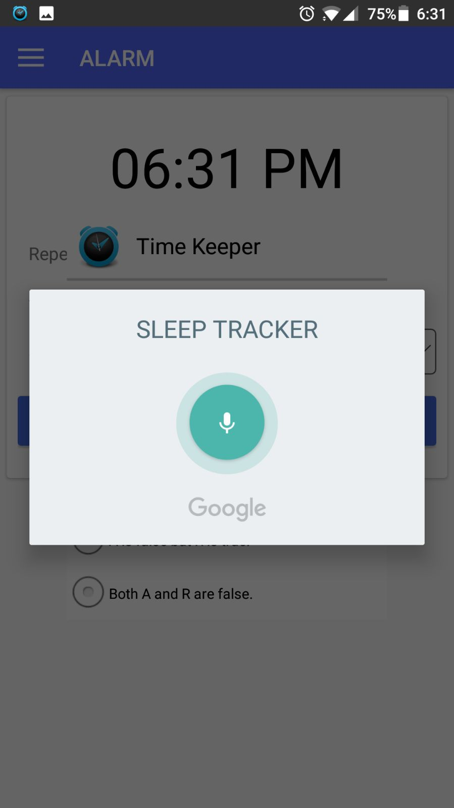

**Contributors:**

* Srinivas Potluri – 25%
* Swaroop Chitiprolu– 25%
* Seshu Sai Prasanna Chennupati – 25%
* Sampath Boddeti – 25%

**7.Bibliography**

#### 1.<http://creately.com/>2.<http://developers.facebook.com/>

3. <http://developers.google.com/>

4. <http://www.stackoverflow.com/>